SUBCOURSE EDITION
0D0485 8

BATTLE DAMAGE ASSESSMENT AND
REPAIR (BDAR) – M1 TANK


US ARMY M1 ABRAMS TANK SYSTEMS MECHANIC

MOS/SKILL LEVEL: 63E30

BATTLE DAMAGE ASSESSMENT AND
REPAIR (BDAR) -- M1 TANK

SUBCOURSE NO. 0D0485
Edition 8

US Army Correspondence
Course Program

5 Credit Hours
NEW: 1988

GENERAL

The purpose of this subcourse is to increase knowledge of the battlefield damage assessment and repair program and of the fault assessment tables.

Five credit hours are awarded for successful completion of this subcourse. It consists of one lesson of two tasks and an examination as follows:

Lesson 1: BATTLE DAMAGE ASSESSMENT AND REPAIR
(BDAR) PROGRAM AND FAULT ASSESSMENT
TABLES

TASK 1: Explain the battle damage assessment and repair (BDAR) program.

TASK 2: Describe the function of battle damage assessment and repair (BDAR) fault assessment tables.

i
BAT. DAMAGE ASSES. & REPR. - M1 TANK - OD0485

TABLE OF CONTENTS

Section Page

TITLE i

TABLE OF CONTENTS ii

Lesson 1: BATTLE DAMAGE ASSESSMENT AND REPAIR
(BDAR) PROGRAM AND FAULT ASSESSMENT
TABLES 1

Task 1: Explain the battle damage
assessment and repair (BDAR) program 1

Task 2: Describe the function of battle
damage assessment and repair (BDAR) fault
assessment tables 14

Practical Exercise 1 40

Answers to Practical Exercise 1 42

REFERENCES 44

ii
BAT. DAMAGE ASSES. & REPR. - M1 TANK - OD0485 – LESSON 1/TASK 1

LESSON 1

BATTLE DAMAGE ASSESSMENT AND REPAIR (BDAR)
PROGRAM AND FAULT ASSESSMENT TABLES

TASK 1. Explain the battle damage assessment and repair (BDAR) program.

CONDITIONS

Within a self-study environment and given the subcourse text, without assistance.

STANDARDS

Within 2 hours

REFERENCES

No supplementary references are needed for this task.

1. Introduction

Battle damage assessment and repair procedures are applicable to all combat vehicles and can be used by operators, unit, and intermediate direct support/intermediate general support (IDS/IGS) maintenance personnel under the forward support maintenance concept during combat.

The purpose of battle damage assessment and repair is to rapidly return disabled combat vehicles to the operational commander by expediently fixing, bypassing, or jury-rigging components to restore the minimum essential systems required for the support of the specific combat mission, or to enable the tank to self-recover. These repairs may be temporary and may not restore full performance capability. For this reason, battlefield damage assessment and repair fixes must be repaired by standard maintenance procedures as soon as practicable after the mission is completed.

1
BAT. DAMAGE ASSES. & REPR. - M1 TANK - OD0485 – LESSON 1/TASK 1

There are two technical manuals that deal specifically with battlefield damage assessment and repair (BDAR) for the M1 tank; TM 9-2350-255-BD and TM 9-2350-276-BD. TM 9-2350-255-BD describes the BDAR procedures applicable to the M1 Abrams, tank and TM 9-2350-276-BD covers expedient repairs of a general nature which apply to systems or subsystems common to more than one combat vehicle.

This task will explain the BDAR program, to include: definitions, standards and practices, and responsibilities and tasks.

2. Definitions

a. Battlefield Damage. The term battlefield damage includes all incidents which occur on the battlefield and which prevent the vehicle from accomplishing its mission, such as combat damage, random failures, operator errors, accidents, and wear-out failures.

b. Repair or Fix. The term repair or fix includes any expedient action that returns a damaged part or assembly to a full, or to an acceptably degraded operating condition, including:

- Short cuts in parts removal or installation.

- Installation of components from other vehicles that can be modified to fit or interchange with components on the M1 tank.

- Repair, using M1 parts that serve a noncritical function elsewhere on the same M1 tank, for the purpose of restoring a critical function.

- Bypassing non-critical components in order to restore basic functional capability.

- Expeditious cannibalization procedures.

- Fabrication of parts from kits or readily available materials.

- Jury-rigging.

- Use of substitute fuels, fluids, or lubricants.

2
BAT. DAMAGE ASSES. & REPR. - M1 TANK - OD0485 – LESSON 1/TASK 1

c. Damage Assessment. Damage assessment is a procedure to determine rapidly what is damaged, whether it is repairable, what assets are required to make the repair, who can do the repair (i.e. crew, maintenance team (MT), or maintenance support team (MST)), and where the repair should be made. The assessment procedure includes the following steps:

(1) Determine if the repair can be deferred.

(2) Isolate the damaged areas and components.

(3) Determine-which components must be fixed.

(4) Prescribe fixes.

(5) Determine if parts or components, materials, and tools are available.

(6) Estimate the manpower and skill required.

(7) Estimate the total time (clock-hours) required to make the repair.

(8) Establish the priority of the fixes.

(9) Decide where the fix shall be performed.

(10) Decide if recovery is necessary and to what location.

d. Maintenance Team (MT). A maintenance team consists of unit maintenance mechanics, trained in assessing battle damage and field repair procedures. MTs are called to out-of-action vehicles to supplement (or confirm) the crew's original damage assessment. MT assessment determines if field repairs will be conducted or if recovery is required. Depending on available time, the MT will assist the crew in restoring the vehicle to mission capability.

e. Maintenance Support Team (MST). A maintenance support team consists of intermediate direct support/intermediate general support mechanics and technical specialists, trained in assessing battle damage, in addition to their specialty. MST are called by the MT when vehicle damage exceeds MT assessment capability, or unit maintenance repair capability.

3
BAT. DAMAGE ASSES. & REPR. - M1 TANK - OD0485 – LESSON 1/TASK 1

f. MT/MST Assessor. The MT/MST assessor is a senior member of the forward MT/MST. He is an M1 systems mechanic/technician, trained in BDAR techniques. He must know:

- The unit's mission and the commander's requirements.

- The maintenance capability of the unit, including the available skills, tools, repair parts, and materials.

- How to detect contamination and effect decontamination of equipment.

- The unit's maintenance workload.

- The maintenance capability of all accessible rally and maintenance collection points.

g. Fully Mission Capable. The term fully mission capable (FMC) means that the tank can perform all its combat missions without endangering the life of the crew. To be FMC, the tank must be complete and fully operable with no faults listed in the EQUIPMENT IS NOT READY/AVAILABLE IF column of the operator's Preventive Maintenance Checks and Services (PMCS), found in TM 9-2350-255-10-1.

h. Combat Capable. The term combat capable means that the tank meets the minimum functional combat capability requirements.

i. Combat Emergency Capable. The term combat emergency capable means that the tank meets the needs for specific tactical maneuver or firing missions; however, all systems are not functional. Also, additional damage, due to the nature of an expedient repair, may occur to the tank if it is used. The commander must decide if these limitations are acceptable for that specific emergency situation.

j. Self-Recovery Capable. The term self-recovery capable means that the tank meets the needs for recovery under self-power. It could include hazardous equipment conditions, such as partial brakes or limited steering.

k. Cannibalization. The term cannibalization, as used in battlefield damage assessment and repair, means any use of

4
BAT. DAMAGE ASSES. & REPR. - M1 TANK - OD0485 – LESSON 1/TASK 1

repair parts or components obtained from another combat vehicle, either damaged or of lower priority to the immediate mission.

3. Standards and Practices

a. BDAR Characteristics. BDAR capability requires simplicity, speed, and effectiveness. Some BDAR procedures include repair techniques that violate standard peacetime maintenance practices. In a combat emergency situation, greater risks are necessary and acceptable.

b. Training. The unit commander should assure that an adequate number of members of his organization, including supervisors, are trained in BDAR procedures applicable to his equipment. Each tank crewman should be trained to perform initial battle damage assessment for his crew position.

c. Waiver of Precautions. Under combat conditions, BDAR may be performed on M1 tanks which are fueled and/or armed. Other similar precautions may be waived at the discretion of the commander.

d. Environment. BDAR may be required in a chemically toxic environment, or under other adverse conditions which impose severe limitations on personnel, facilities, equipment, and materials. Performance of repair tasks may be necessary while wearing protective gear. Expedient decontamination procedures are described in FM 3-220.

e. Serviceability and Operability (Operating Characteristics). The minimum functional combat capability (MFCC) criteria for the M1 Abrams Tank are as follows:

NOTE

These criteria may be waived for recovery, or if the tactical situation demands otherwise (combat emergency capable).

(1) Armament and Fire Control.

(a) Turret must traverse 360 degrees and elevate, with no oscillations, either manually or by power.

5
BAT. DAMAGE ASSES. & REPR. - M1 TANK - OD0485 – LESSON 1/TASK 1

(b) Main gun must be capable of firing without damage to the recoil system.

(c) Must retain an operational fire control device (primary or secondary).

(2) Mobility.

(a) Must have an operational track on both sides of the tank.

(b) May be missing roadwheels, with the following stipulations:

1 May not be missing more than a total of three roadwheels on either side.

2 The first, second, and last roadwheel stations must each have complete sets of roadwheels.

3 There must be a complete set of roadwheels between any two incomplete roadwheel stations.

(c) Drive train must be functional and must be capable of reverse and at least one forward gear.

(d) Power train performance degradation cannot exceed a level which would cause the tank to be incapable of traveling 15 mph on an unimproved, level road.

(e) Must be capable of normal braking/stopping from 15 mph, brakes must hold on a 30 percent slope.

(f) Vehicle steering system must be operational.

(3) Communications. Must have intercom between tank commander and driver.

f. Permanent Repair. Upon completion of the mission, or at the next practicable opportunity, the vehicle will be recovered or evacuated to the appropriate maintenance facility for permanent standard repair, as required.

4. Responsibilities and Tasks

a. General. Battlefield damage assessment and repair procedures

6
BAT. DAMAGE ASSES. & REPR. - M1 TANK - OD0485 – LESSON 1/TASK 1

are applicable at all levels, from crew through intermediate general support maintenance, depending on the extent of the damage, the time available, the skills required, and the parts, components, tools, and whatever action is necessary and possible to restore the tank to the combat ready condition required for continuation of the mission.

Battlefield damage repair kits, consisting of essential tools, spare parts and expendable supplies, may be carried on board each tank to enable the crew to rapidly fix the simplest and most common types of damage/failure.

b. Commander and Crew. The crew of the damaged vehicle will make the first assessment immediately after damage has occurred. Crew members will provide the tank commander with an initial damage assessment, which will include notice of system failure and all major vehicle systems visibly damaged, inoperative or impaired. If possible, all systems will be checked at the same time by different crew members. If the failure is due to hostile fire, the report will include the location of impact and the manning status. Immediacy of the report is more important than how long it will take to get back into action. The initial report, therefore, may omit repair time estimates. The tank commander must make an initial out-of-action report to the platoon leader, including these essentials:

- Tank damaged (out-of-action or impaired).

- Location of tank.

- Firepower status.

- Mobility status.

- Manning status.

- Current and anticipated enemy action.

If communication capability is damaged, the tank commander should approach the nearest friendly radio and make his report.

In the forward battle area, it is imperative that the crew attempt to move the tank to a covered or concealed position to prevent additional combat damage. This is the first priority.

7
BAT. DAMAGE ASSES. & REPR. - M1 TANK - OD0485 – LESSON 1/TASK 1

If the tank is not capable of self movement, use any vehicle, including other tanks to recover the vehicle or to get concealment; If this is not possible, then at least the turret should be turned in the direction of engaging fires, in order to limit damage and to possibly return fire.

A safety check should be made for any obvious hazards. The safety check is as follows:

(1) Is there an ammunition round in the tube?

(2) Are any ammunition rounds critical, due to shock, fire, or physical damage?

(3) Have any combustibles, such as fuel, hydraulic fluid, or oil leaked or accumulated?

(4) Does wiring appear to be safe? Could arcing occur to stored ammo or leaking combustibles?

(5) Is the fire extinguishing system operational? If not, then one crew member should be stationed in the turret with a hand-fire extinguisher to manually operate the turret fire extinguisher. A second crew member should be stationed outside the turret with the other fire extinguisher. Be should also be prepared to manually actuate the engine compartment fire extinguisher.

(6) A functional/operational test should be performed on those systems which appear undamaged. For systems with a built-in self-test feature, this will be used. Only those systems found to be damaged or inoperative need be identified.

The tank commander will report to the platoon leader the results of the crew's damage assessment, naming the major known causes of the vehicle's immobility and/,or lack of fire power. If repair by the crew is possible, he will report a total estimated repair time and identify the functions that should be restored.

The platoon leader will respond with directives and, if required, will call a MT to the location of the damaged vehicle for assistance. If possible, sufficient information will be provided to enable the MT to bring any needed repair parts or special tools.

8
BAT. DAMAGE ASSES. & REPR. - M1 TANK - OD0485 – LESSON 1/TASK 1

The crew will proceed to make any possible field expedient repairs to restore fire power, communications and/or vehicle mobility to the limit of their skills, materials, and tools available.

c. Unit Maintenance and Maintenance Teams (MT). The unit maintenance team (MT) and assessor operate out of the company or battalion trains. The MT assessor performs his assessment and the maintenance team completes repairs, if possible at the damage site. If the site is within direct fire or under enemy observation, movement to a more secure site in defilade may be necessary. This is still considered on-site.

If the tank has been left unattended in the forward battle area, the immediate area of the tank should be checked for mines and the tank should be checked for booby traps before starting the battle damage assessment. The MT should also make the safety checks that were mentioned in paragraph 4b on page 8. The MT assessment will be more thorough than the crew's, using unit maintenance support tools and equipment as needed. MT assessment includes:

(1) Reviewing the crew's out-of-action report.

(2) Interviewing commander and crew, if available.

(3) Visually inspecting damaged parts and systems.

(4) Performing a self-test.

(5) Making tests with organizational test equipment, if required.

(6) Performing additional vehicle operational tests, as necessary.

Using this information and following the six steps outlined above, the MT will:

- Determine what must be repaired or replaced.

- Determine the sequence and priority of repair actions.

- Estimate repair times for each repair task.

9
BAT. DAMAGE ASSES. & REPR. - M1 TANK - OD0485 – LESSON 1/TASK 1

- Total the repair task times and determine if the repairs can be performed in the time available.

- Determine repair location and, if other than on-site, arrange for recovery of the vehicle to the repair site.

If all the critical repairs can be made within the available time, with the skills, materials, tools, and equipment at hand, the MT, assisted by the crew, will proceed with the on-site repair site.

If the damage exceeds the repair capability of the MT and time is available for an MST on-site fix, the MST shall be called.

If time for an MST on-site fix is not available, but the tank is repairable, the MT shall provide for recovery of the tank to a designated collection point.

If the tank is not repairable, the MT shall provide for one of the following:

- Recovery to a maintenance collection point for evacuation to the rear.

- On-site stripping (if approved by intermediate direct support (IDS) or MST).

- Abandonment/destruction (if directed by the commander).

Tank hulls should never be abandoned if recovery/evacuation is possible because hulls can almost always be rebuilt, no matter how badly damaged they are. If the tank is damaged catastrophically and evacuation is not possible, remove items in the following order:

- Needed spares on-site.

- Sensitive, high value, limited size items.

- Other needed spares.

If the vehicle is contaminated, the MT shall mark the vehicle with contamination markers and arrange for recovery to a decontaminated site.

10
BAT. DAMAGE ASSES. & REPR. - M1 TANK - OD0485 – LESSON 1/TASK 1

d. Intermediate Direct Support/Intermediate General Support (IDS/IGS) Maintenance Support Team. The MST shall assist the MT as needed, using intermediate direct support maintenance tools and equipment. MST assessment and repair procedures are the same as those of the MT, except that they are employed at a higher maintenance level. If possible, the MT will tell the MST what tools and spare parts are needed to perform the repairs. While waiting for the MST to arrive, the crew, under the supervision of the MT, will open up the vehicle and make it ready for the MST, when it arrives, to perform the BDAR.

Damaged tanks removed to designated repair sites shall be selected for repair by the MST in order of:

(1) Most essential to the completion of the mission.

(2) Can be repaired in the least amount of time.

e. Time Limits for Replacing Damage. In combat, the time available for BDAR is limited. One of the factors to be considered in the selection of a repair site is the amount of time available at the site, based on the tactical situation. Every assessment must include an estimate of total elapsed time for all tasks required to restore the vehicle. The time available at the selected repair site must equal or exceed the estimated time required to accomplish all tasks associated with the BDAR.

Determining where BDAR will take place should be based on the guidelines in table 1, on the following page. These are the general rules which must be adjusted by the commander, based on his best estimate of how the most responsive maintenance support can be provided. He must consider the tactical situation, maintenance backlog, personnel, tools, test, measurement, and diagnostic equipment (TMDE), and the repair parts available. The guidelines are based on a defensive scenario and can be adjusted when applied to the offense.

f. Recording BDAR Repairs. All -components of an M1 tank, which are repaired using BDAR or other expedient techniques, should be marked with a DD Form 1577, or similar conspicuous tag. It is

11
BAT. DAMAGE ASSES. & REPR. - M1 TANK - OD0485 – LESSON 1/TASK 1

not necessary to fill out the form. The purpose of marking an item which has been repaired using BDAR techniques is to quickly enable mechanics to recognize that part when the vehicle is subsequently returned for permanent standard repair.

Since it is impractical to attach tags to expediently repaired components located on the outside of the vehicle, the fix shall be noted on DD Form 1577 or similar tag, and the tags stored in the compartment normally reserved for the vehicle log book.

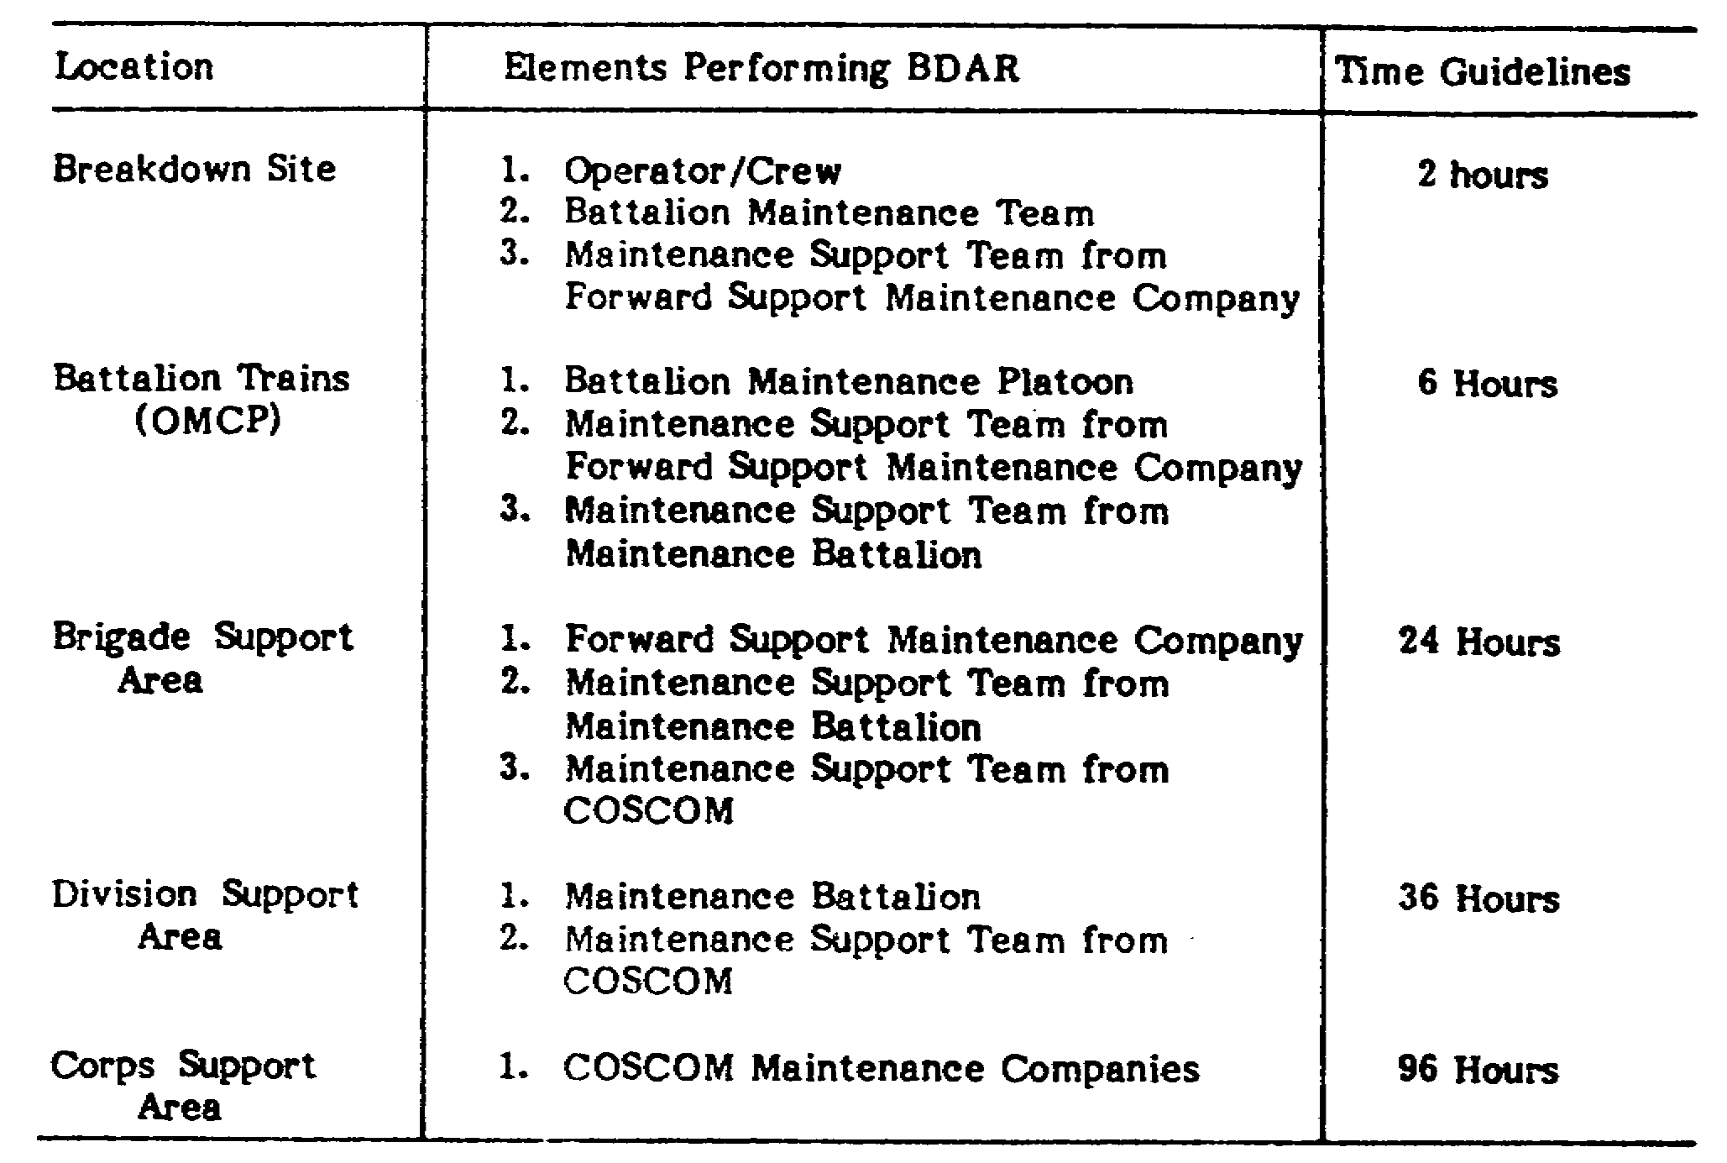

TABLE 1. SUMMARY OF BDAR TIME GUIDELINES

A tag should also be conspicuously placed in the tank commander's position when a BDAR procedure has resulted in a degraded operating capability. This tag should be marked "BDAR" and noted with its specific limitations or cautions.

When a component is cannibalized from a repairable vehicle, a tag should be attached in the space created by the missing part, to alert downstream repair personnel quickly that the part has been removed.

When the vehicle is recovered/evacuated for permanent standard repair, and DA Forms 2404 and 2407 are used, the notation

12
BAT. DAMAGE ASSES. & REPR. - M1 TANK - OD0485 – LESSON 1/TASK 1

"BDAR" shall be added in the space provided for description of deficiencies. These forms are then distributed in accordance to the standing operating procedure (SOP) and DA Pam 738-750.

5. Conclusion

This task provided an introduction to the battlefield damage assessment and repair program; it included definitions, standards and practices, and responsibilities and tasks. The next task will describe the use of the program when performing assessment on the M1 tank, using general and specific fault assessment tables.

13
BAT. DAMAGE ASSES. & REPR. - M1 TANK - OD0485 – LESSON 1/TASK 2

LESSON 1

BATTLE DAMAGE ASSESSMENT AND REPAIR (BDAR)
PROGRAM AND FAULT ASSESSMENT TABLES

TASK 2. Describe the function of battle damage
assessment and repair (BDAR) fault
assessment tables.

CONDITIONS

Within a self-study environment and given the subcourse text, without assistance.

STANDARDS

Within 2 hours

REFERENCES

No supplementary references are needed for this task.

1. Introduction

Fault assessment tables are used to assess and identify the procedures for fixing the battlefield damage that prevents the M1 tank from moving, shooting, and communicating.

This task will provide information for assessing battlefield damage using fault assessment tables and repairing battlefield damage using detailed assessment procedures and expedient repair procedures. This task will include examples of possible battlefield damage and the procedures needed for expedient repair.

2. Application of Battlefield Damage Assessment

When assessing the battlefield damage on an M1 tank, TM 9-2350-255-BD should be used in conjunction with the operator's manuals (TM 9-2350-255-10 series) and the lubrication order (LO 9-2350-255-12).

14
BAT. DAMAGE ASSES. & REPR. - M1 TANK - OD0485 – LESSON 1/TASK 2

The following procedures should be performed in order to find and fix battlefield damages:

a. Do the preventive maintenance checks and services (PMCS) in the operator's manual (TM 9-2350-255-10-1) and the lubrication order (LO 9-2350-255-12). At the same time look for obvious damage to the tank.

b. If applicable, do the troubleshooting/repair procedures recommended in the operator's manual (TM 9-2350-255-10-3).

c. If you find the problem, determine its effect on the operation (mobility, firepower, communication) of the tank.

d. If you cannot find the problem after doing the PMCS and the procedures in the operator's manual and lubrication order, use the general fault assessment tables in TM 9-2350-255-BD. These tables are presented on pages 17 and 18 of this task:

(1) Table 2 is for mobility.

(2) Table 3 is for firepower.

(3) Table 4 is for communication.

e. If the problem does not affect tank operation, the commander will decide whether to attempt a fix or continue with the mission.

f. If the damage does affect tank operation, do one of the following:

(1) Replace the bad part or assembly with a good one (from supply or from another vehicle or tank).

(2) Replace the bad part or assembly with a substitute, if one exists.

(3) Use the expedient repair procedures in TM 9-2350-255-BD.

g. After repairing the damaged system, replace all lost fluids and/or lubricants. If those specified are not available, appendix B in TM 9-2350-255-BD should be referred to for a possible substitute.

15
BAT. DAMAGE ASSES. & REPR. - M1 TANK - OD0485 – LESSON 1/TASK 2

3. Using Assessment Techniques to Perform Battlefield Damage Repair

a. General Fault Assessment Tables. Tables 2, 3, and 4 will direct the mechanic to a specific fault assessment table, found in chapters 3 through 12 of TM 9-2350-255-BD. The introduction in each chapter -includes an overview of that particular system and the basic information and diagrams that can be used to fix the problem, or apply techniques found in the general fixes section of TM 9-2350-276-BD.

b. Specific Fault Assessment Tables. The specific fault assessment tables ask questions that are more specific than the general tables, and usually refer the soldier to a detailed assessment procedure or expedient repair procedure.

c. Detailed Assessment Procedures. The detailed assessment procedures are step-by-step procedures that isolate the problem and lead to an expedient repair procedure, if one exists.

d. Expedient Repair Procedures. The following information describes the content of an expedient repair procedure:

(1) Contains general information about the problem.

(2) Lists materiel and/or tools required other than those commonly available to the crew, MT, and MST. If the listed items are not available, improvise. Anything that will do the job is acceptable.

(3) Lists the estimated number of soldiers needed and the estimated time required to complete the repair.

(4) States the operational limitations caused by the repair action necessary to avoid imposing further damage/degradation to the tank.

(5) Provides other expedient options the soldier can use depending on the availability of personnel, materials, tools, and/or time. This does not include standard maintenance or recovery procedures.

e. Expedient Repair Procedures Index. At the back of each chapter in TM 9-2350-255-BD, there is an index of the procedures contained in that chapter. If you know exactly what your

16
BAT. DAMAGE ASSES. & REPR. - M1 TANK - OD0485 – LESSON 1/TASK 2

problem is, you can use the index to find the proper expedient repair procedure.

f. Using Fault Assessment Tables.

The information below will explain the steps involved in using a fault assessment table to find the appropriate repair procedure.

(1) Answer the first question in the table (use table 2 as an example).

(2) Follow your answer (Yes or No) down until you come to another Yes, No, or X.

(3) Answer the question for that Yes, No, or, for an X, do step (5).

(4) Repeat steps (2) and (3) until you come to an X. (When you answer the last question, dependent upon your symptom, the Yes or No will lead to an X.)

(5) Follow the X across to the left and follow the instruction.

g. General Fault Assessment. The following tables are the general fault assessment tables that are used to check the M1 tank for mobility, firepower, or communication problems.

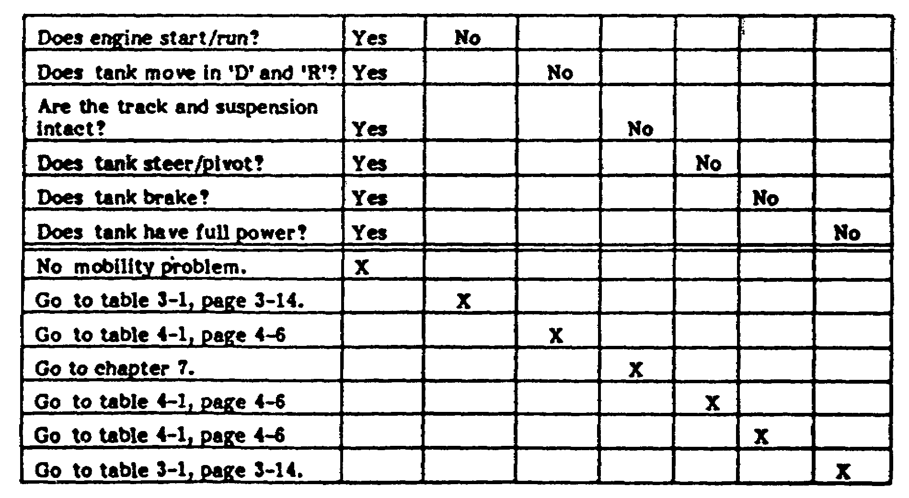
TABLE 2. MOBILITY.

17
BAT. DAMAGE ASSES. & REPR. - M1 TANK - OD0485 – LESSON 1/TASK 2

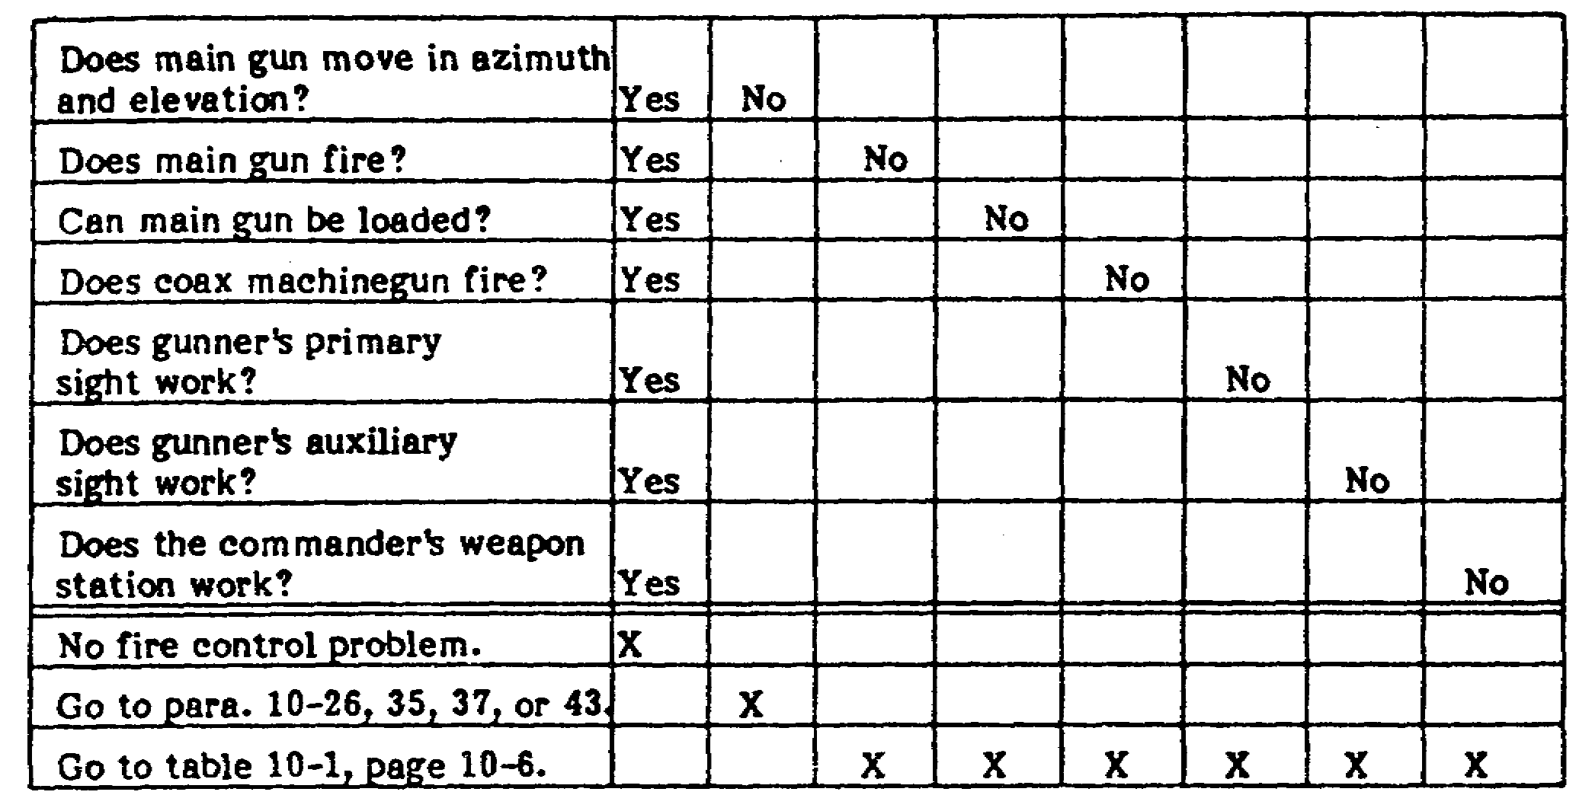
TABLE 3. FIREPOWER.

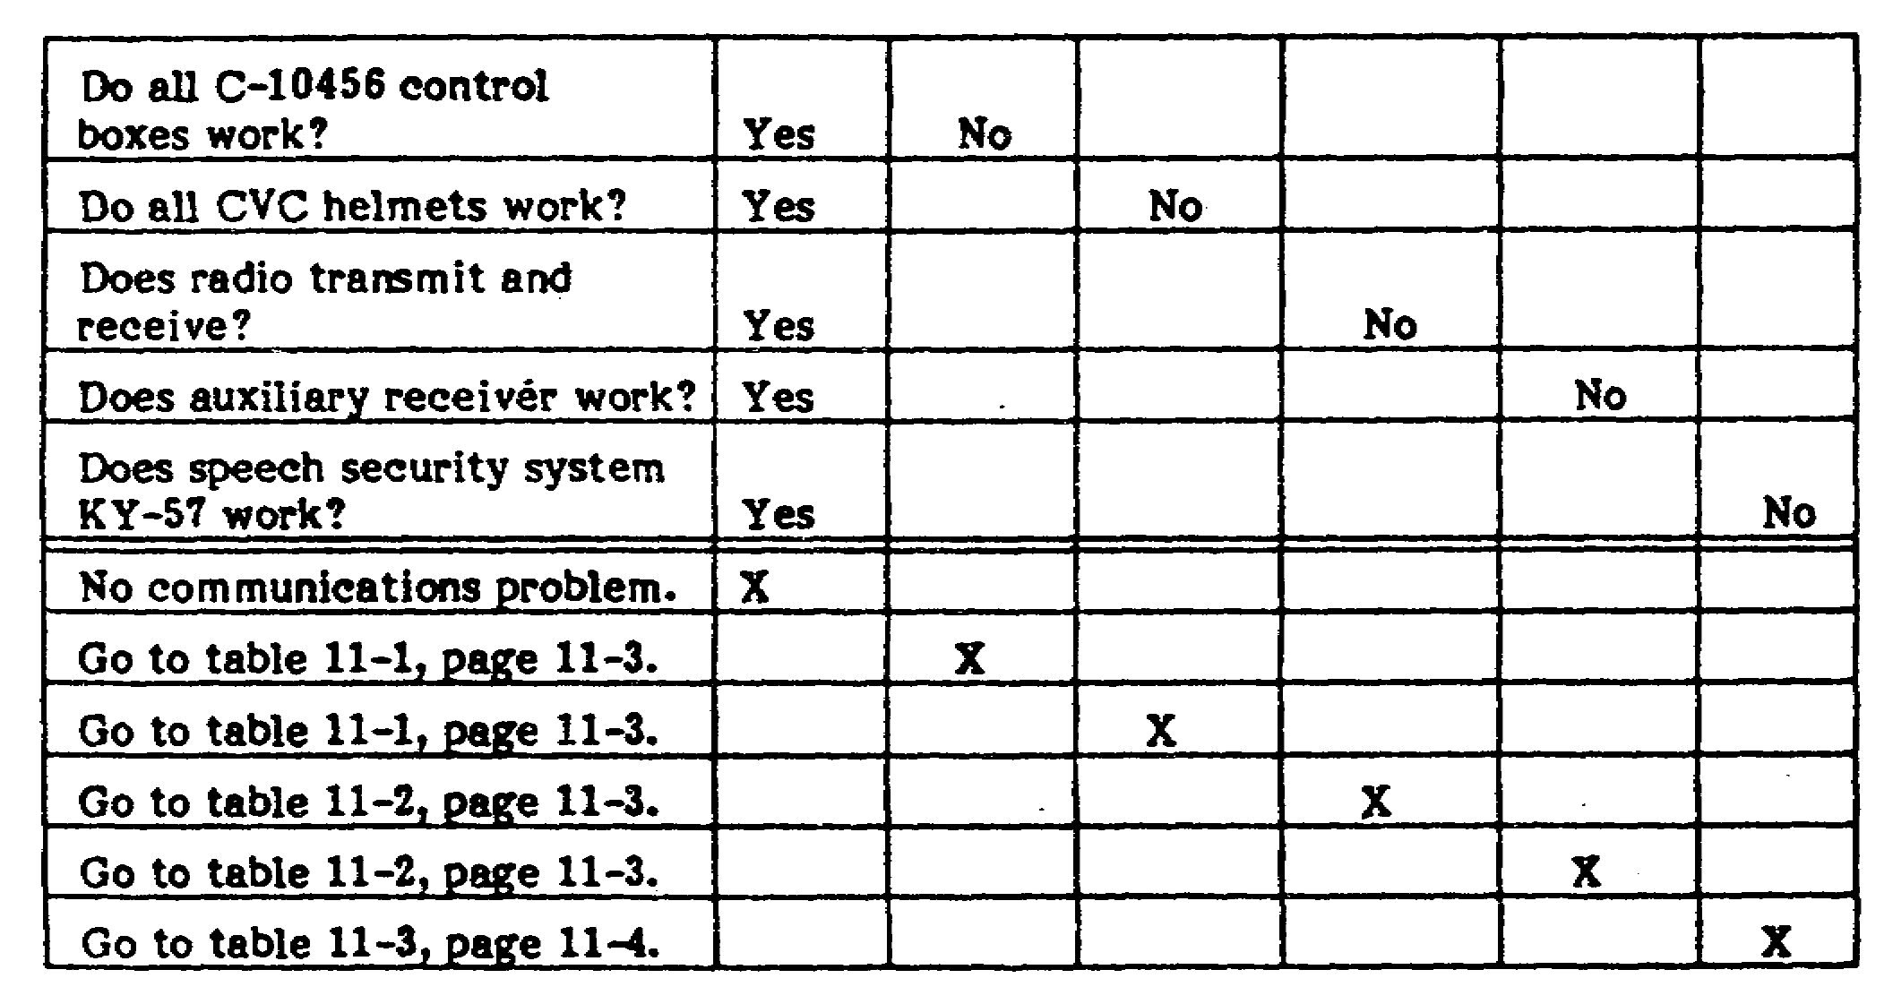
TABLE 4. COMMUNICATIONS.

18
BAT. DAMAGE ASSES. & REPR. - M1 TANK - OD0485 – LESSON 1/TASK 2

4. Battlefield Damage Assessment and Repair Forms

There are certain forms that are used in assessing battlefield damage. These forms, called combat damage report forms, are designed to assist commanders in rapidly assessing battlefield damaged equipment, systematically assessing equipment to determine which subsystem(s) are affected and the time, personnel and material required to effect repair. The forms will also assist in performing vehicle triage, which is defined as a system of deciding in what order battlefield damaged equipment will receive repair, according to time, urgency, material, and personnel required to accomplish the repair.

NOTE

These forms are locally reproducible and should be prepared in necessary quantities to support local needs.

The battlefield damage forms are designed to ensure that all necessary aspects of combat capability are evaluated during the assessment process. The sequence of the assessment procedures should be as follows:

(1) Visually inspect (repair if necessary).

(2) Functionally test (repair if necessary).

(3) Assess the performance.

The net assessment and field fixes will enable the M1 tank to continue the mission or self-recover, but will typically be more useful to the MT/MST for scheduling and accomplishing both BDAR "quick fixes" and fix-forward repairs. Battlefield damage assessment will also provide the commander with the necessary information for timely decisions as to whether to continue to "fight the vehicle" or recover it at the appropriate level. Battlefield damage should be reported in accordance with local standing operating procedures (SOP).

There are four BDAR forms (BDARF) used when assessing battlefield damage for the M1 tank. They are:

- BDARF-1; for M1 systems assessment summary.

19
BAT. DAMAGE ASSES. & REPR. - M1 TANK - OD0485 – LESSON 1/TASK 2

- BDARF-2; for the hull damage report.

- BDARF-3; for the turret damage report.

- BDARF-4; for the communications damage report.

The battlefield damage assessment and repair form, BDARF-1 (see figure 1 on the following page) is used to determine:

(a) Can the vehicle MOVE, SHOOT, and COMMUNICATE?

(b) What subsystems are affected?

(c) Is the damage repairable?

(d) If repairable, are there limitations?

(e) Estimated time to repair.

(f) Estimated number of soldiers to effect repair.

(g) What materials are required?

(h) Recovery status (recovery vehicle required or self-recover).

Once these facts are known, a determination can be made as to whether the vehicle should be repaired on-site, recovered to a collection point and repaired, or recovered to the rear.

The battlefield damage assessment and repair forms, BDARF-2, -3, and -4 (see figures 2, 3, and 4 on the following pages) address specific systems and subsystems and are used to rapidly assess the damage and determine the appropriate BDAR fix. The portion of this form which addresses parts should be filled out only when the tactical situation permits. Where possible, these forms should follow the damaged equipment, or be sent to the rear as a record of what damages occurred and what repairs were effected and where.

On forms BDARF-2 and -3, the chapter in TM 9-2350-255-BD that covers that specific subsystem is shown. When assessing battlefield damage, refer to those chapters for the specific assessment tables, and the detailed and expedient repair procedures.

20
BAT. DAMAGE ASSES. & REPR. - M1 TANK - OD0485 – LESSON 1/TASK 2

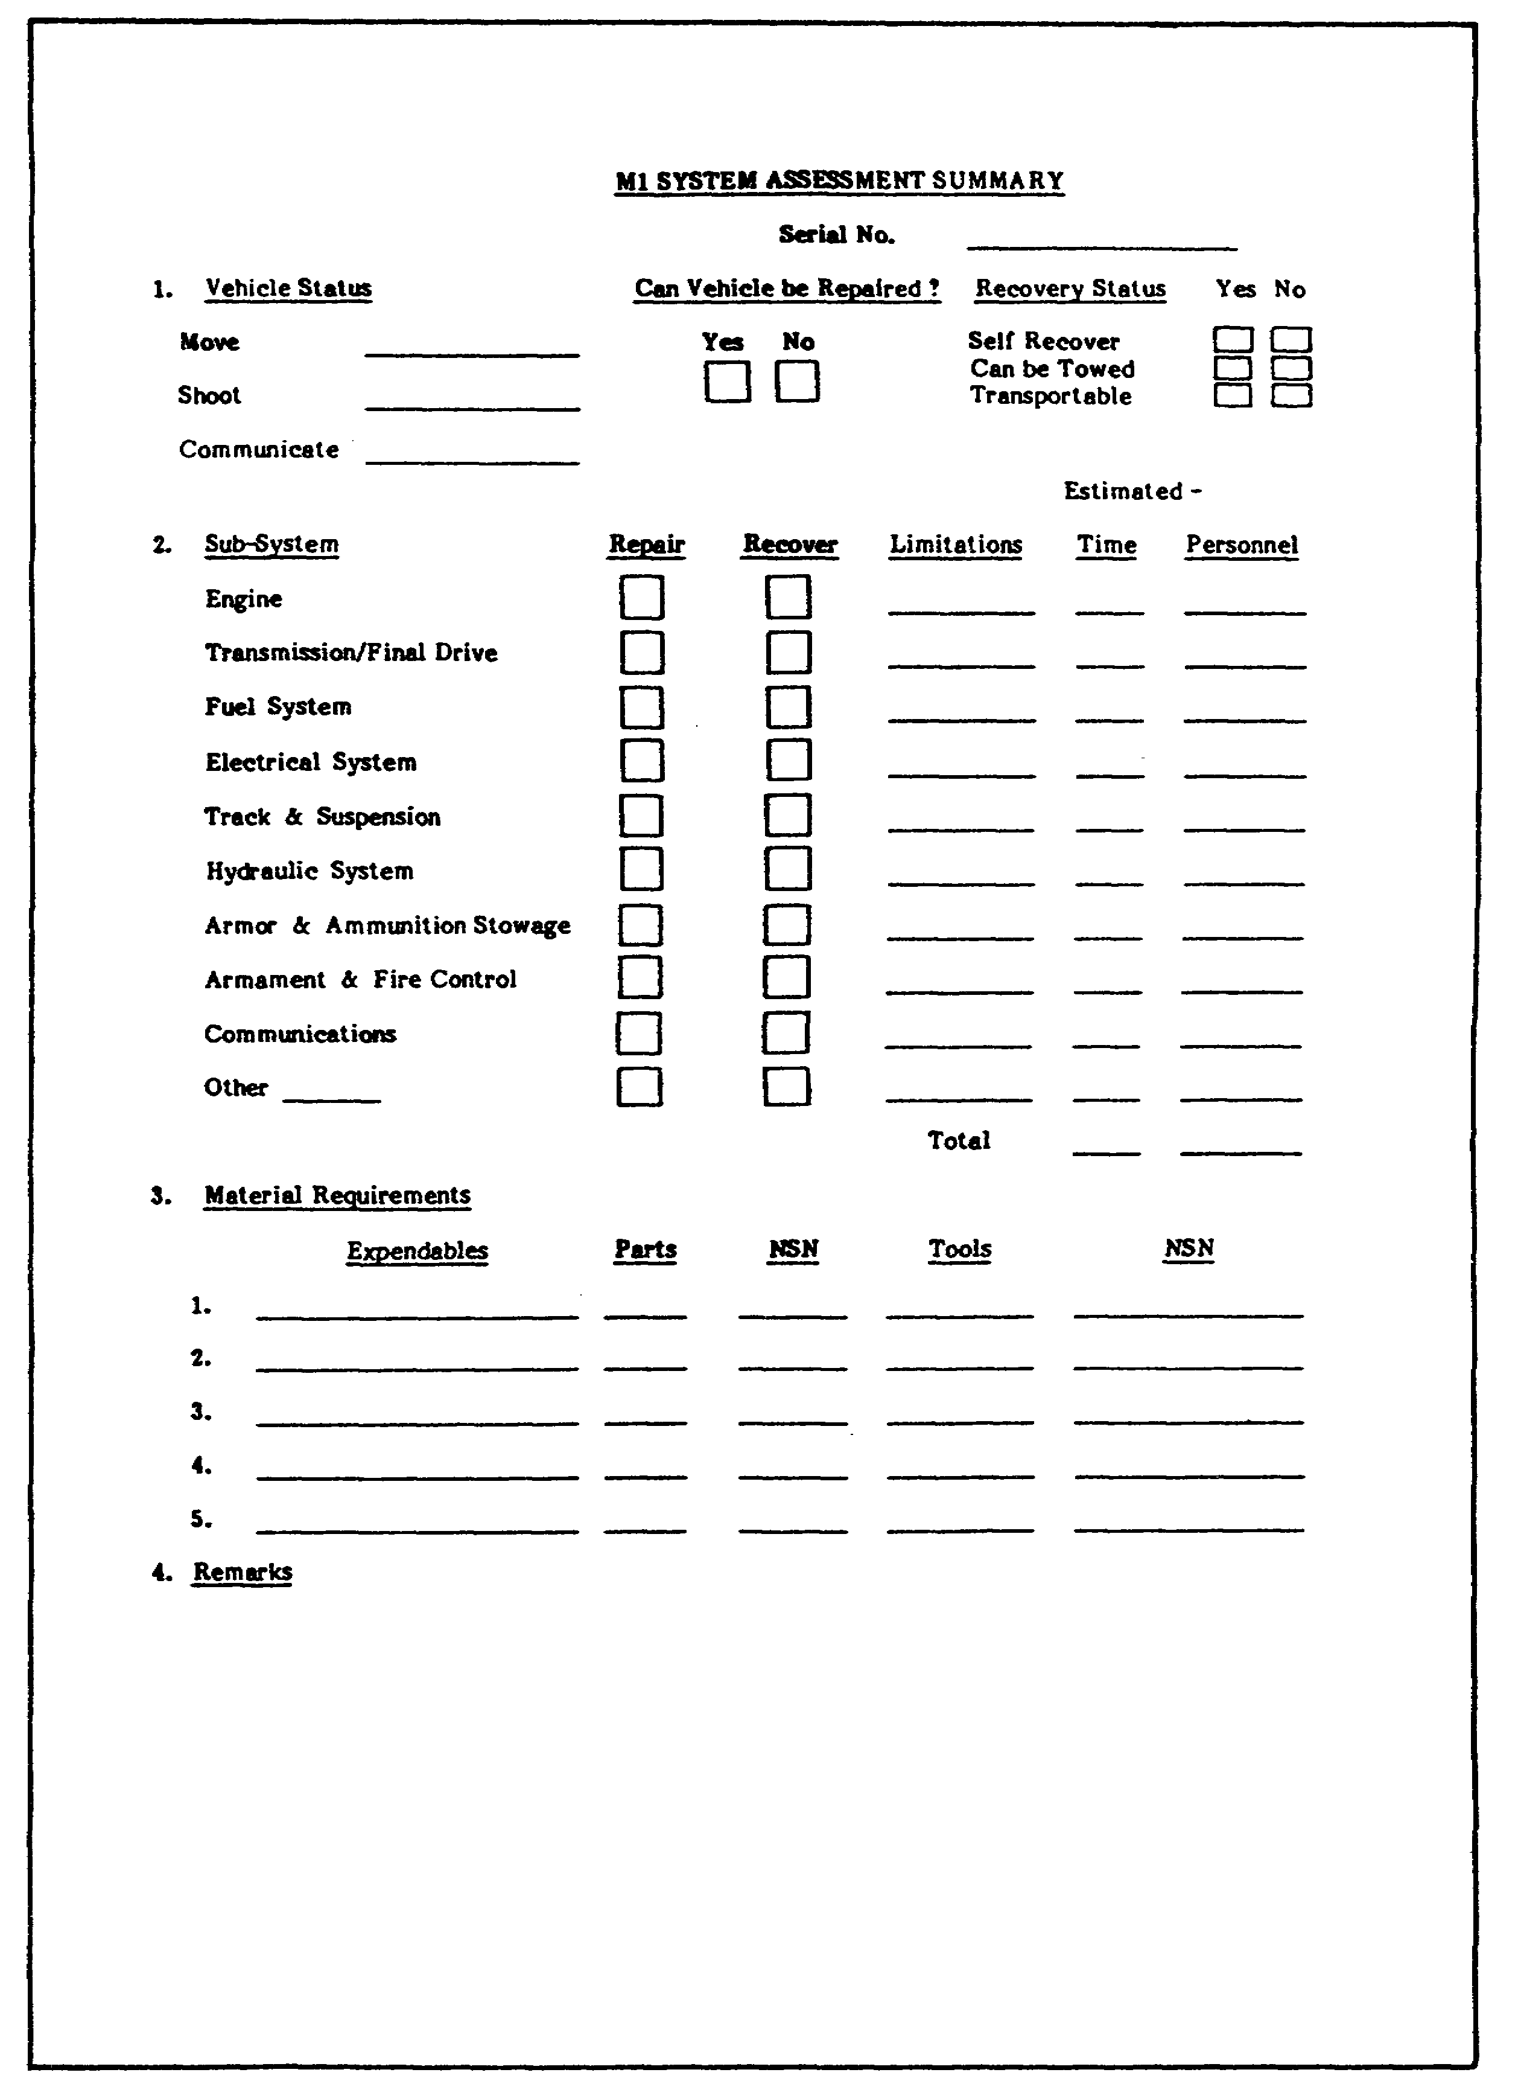

FIGURE 1. BDARF-1.
21
BAT. DAMAGE ASSES. & REPR. - M1 TANK - OD0485 – LESSON 1/TASK 2

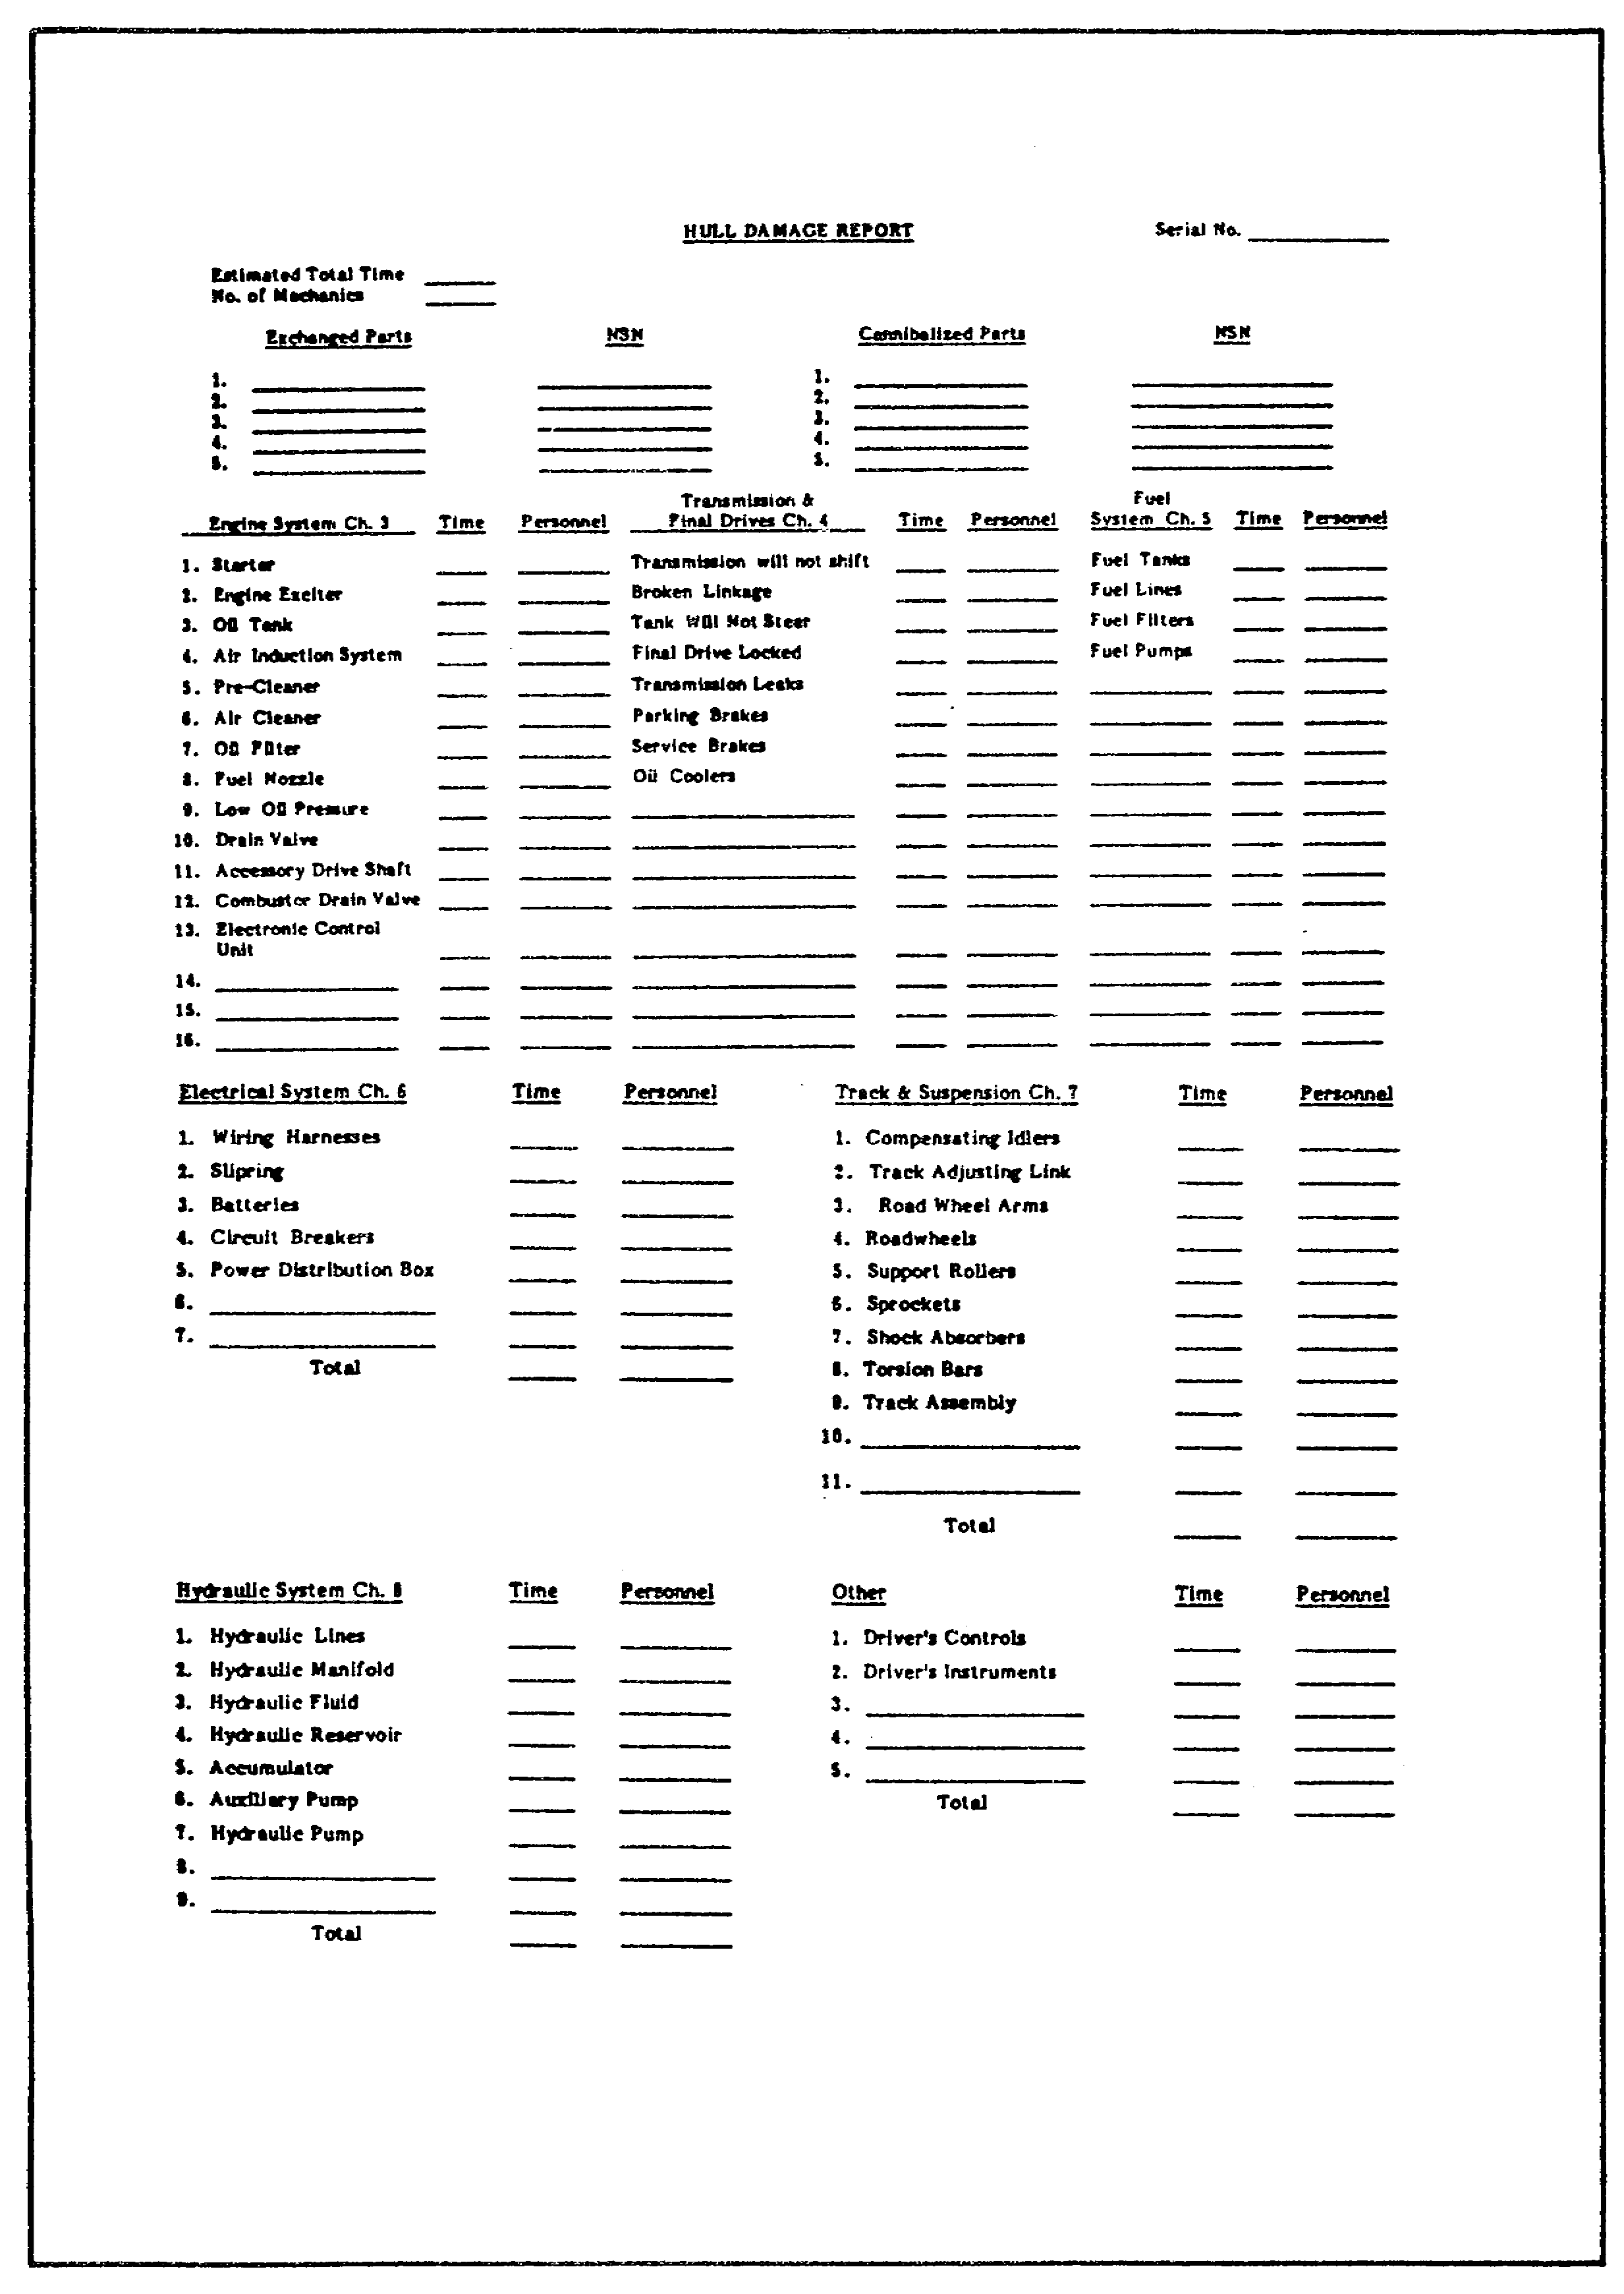

FIGURE 2. BDARF-2.

22
BAT. DAMAGE ASSES. & REPR. - M1 TANK - OD0485 – LESSON 1/TASK 2

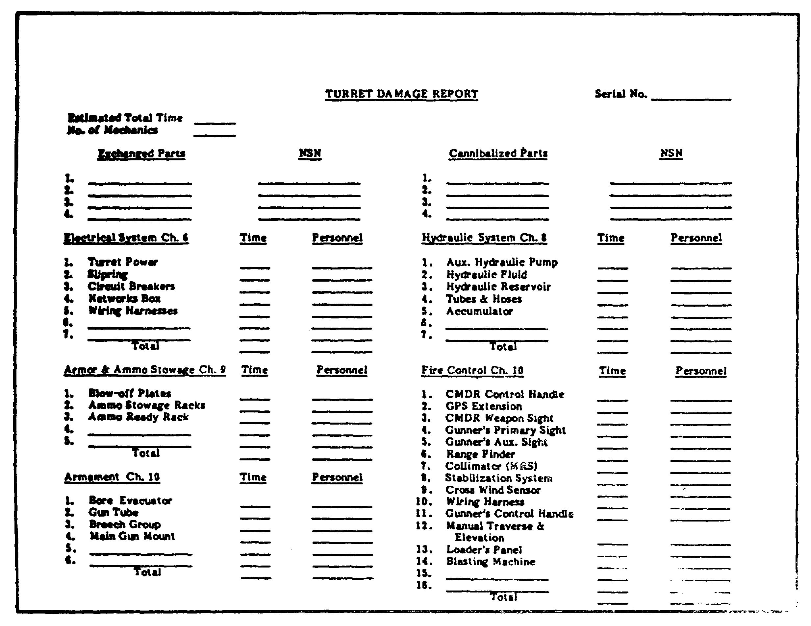

FIGURE 3. BDARF-3.

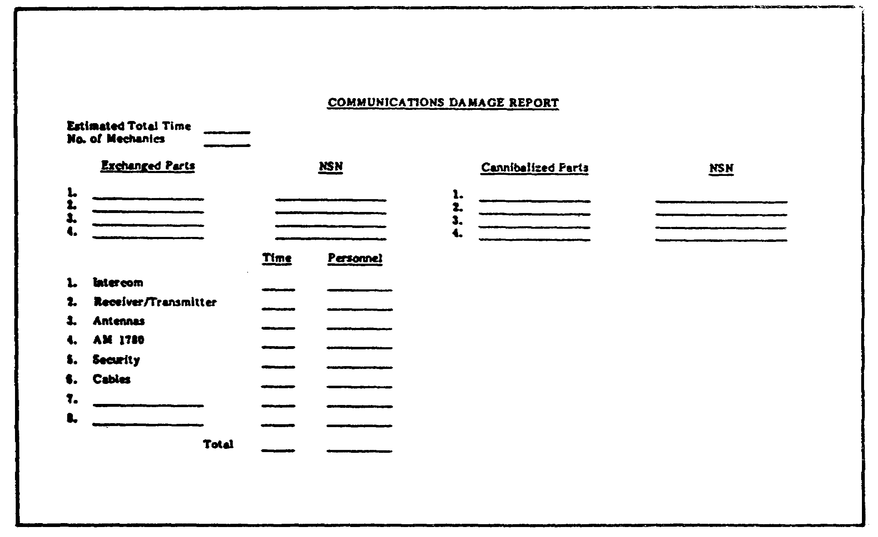

FIGURE 4. BDARF-4.
23
BAT. DAMAGE ASSES. & REPR. - M1 TANK - OD0485 – LESSON 1/TASK 2

5. General Troubleshooting and Maintenance Instructions for Battlefield Damage

The information in the previous sections of this task described the steps used to assess battlefield damage and to repair that damage. This section will contain general instruction on the use and fabrication of jumper wires, the use of the breakout box toolkit, and instruction on the fabrication of field expedient test equipment that may be needed when using the expedient repair procedures.

a. General Instructions. Contained below are the general instructions that should be followed before performing any battlefield damage troubleshooting or maintenance on the M1 tank.

(1) Make sure the troubleshooting and/or maintenance steps in the operator's manual (TM 9-2350-255-10-3) have been completed.

(2) Observe all warnings, cautions, and standard safe work practices, as conditions allow.

(3) Unless stated otherwise, ensure the following tank conditions are met before troubleshooting begins:

- Weapons are safe.

- Main gun is locked.

- Turret is locked.

- Engine is shut down.

- Parking brake is set.

- Vehicle master power is OFF.

- All switches are OFF or in their normal position.

- All circuit breakers are ON.

(4) Use the following general troubleshooting and maintenance instructions:

- Be very careful when reconnecting electrical harnesses. Make sure the pins are aligned, and tighten by hand only.

24
BAT. DAMAGE ASSES. & REPR. - M1 TANK - OD0485 – LESSON 1/TASK 2

- All voltage readings should be positive, unless otherwise stated.

b. Jumper Wires. Jumper wires are commonly used in assessment and repair procedures in the BDAR manual. They are temporary but effective means of bypassing defective electrical circuits. There are several options available to the soldier when a jumper wire is required. Among these options are:

(1) Use the TA1 continuity test probe kit (part of the simplified test equipment M1/fighting vehicle system (STE M1/FVS) test set). It consists of a jumper lead and different size (12, 16, and 20 gauge) pin and socket adapters. However, it does not contain a pin adapter small enough to fit the test jacks.

(2) Strip 1/2 inch of insulation from both ends of any available piece of wire. If the wire is proper gauge (test jack sockets require 22 gauge), twist the wire ends and insert them directly into the sockets.

(a) If the wire is larger gauge than required, pull back the number of wire strands necessary until the proper gauge is obtained. Clip unneeded strands. Twist remaining strands and insert directly into the sockets.

(b) If the wire is smaller gauge than required, strip more insulation from wire ends and fold exposed ends in half. Fold ends as many times as necessary to obtain a snug fit in the socket.

NOTE

Tape the wire to connector face for additional support.

When jumpers are used, make sure that the proper test jack (or breakout box) sockets are selected. Improper selection could result in damage to equipment. It is a good standard practice to insert jumpers into the test jack sockets before turning on master power.

25
BAT. DAMAGE ASSES. & REPR. - M1 TANK - OD0485 – LESSON 1/TASK 2

(3) Use a blank connector matching the test jack or connector where the jumper wires are to be connected. Solder wires to the back of the blank connector in the proper pin locations and install the connector.

c. Breakout Box Tool Kit. The procedures in TM 9-2350-255-BD make extensive use of the test jacks to assess problems and bypass defective electrical circuits. These procedures can be performed by measuring and jumpering right on the test jacks, but a much easier and better method is to use the breakout box toolkit. The breakout box allows easy access and readability of the test jack pins and sockets. The breakout box connects to the test jacks by a cable and adapters supplied with the kit. Figure 5 and figure 6, on the following pages, show the available adapters and connections for the hull components and the turret components. There is a direct correlation between test jack pins and sockets and the breakout box test points (e.g. turret networks box TJ1-14 is electrically the same as test point 14 on the breakout box when it is connected to TJ1 through CABLE NO. 1 and ADAPTER NO. 1). In addition to simplifying assessment, the breakout box can also be used in procedures where jumper wires are used to bypass defective circuits. However, the use of the breakout box as an extension of the test jacks in an expedient repair procedure should be limited, due to having to leave the breakout box with the tank.

d. Field Expedient Test Equipment. Sometimes, in the process of assessing the battlefield damage, it is necessary to make voltage and resistance measurements to determine where the fault is. Standard test equipment (voltmeter, ohmmeter, standing wave ration (SWR) meter, etc.) should be used whenever possible. If standard test equipment is not available, field expedient equipment can be fabricated, using parts commonly found on the tank and in the forward maintenance areas. The following paragraphs provide fabrication instructions for making a voltmeter, ohmmeter, and radio frequency (RF) transmitter output tester.

26
BAT. DAMAGE ASSES. & REPR. - M1 TANK - OD0485 – LESSON 1/TASK 2

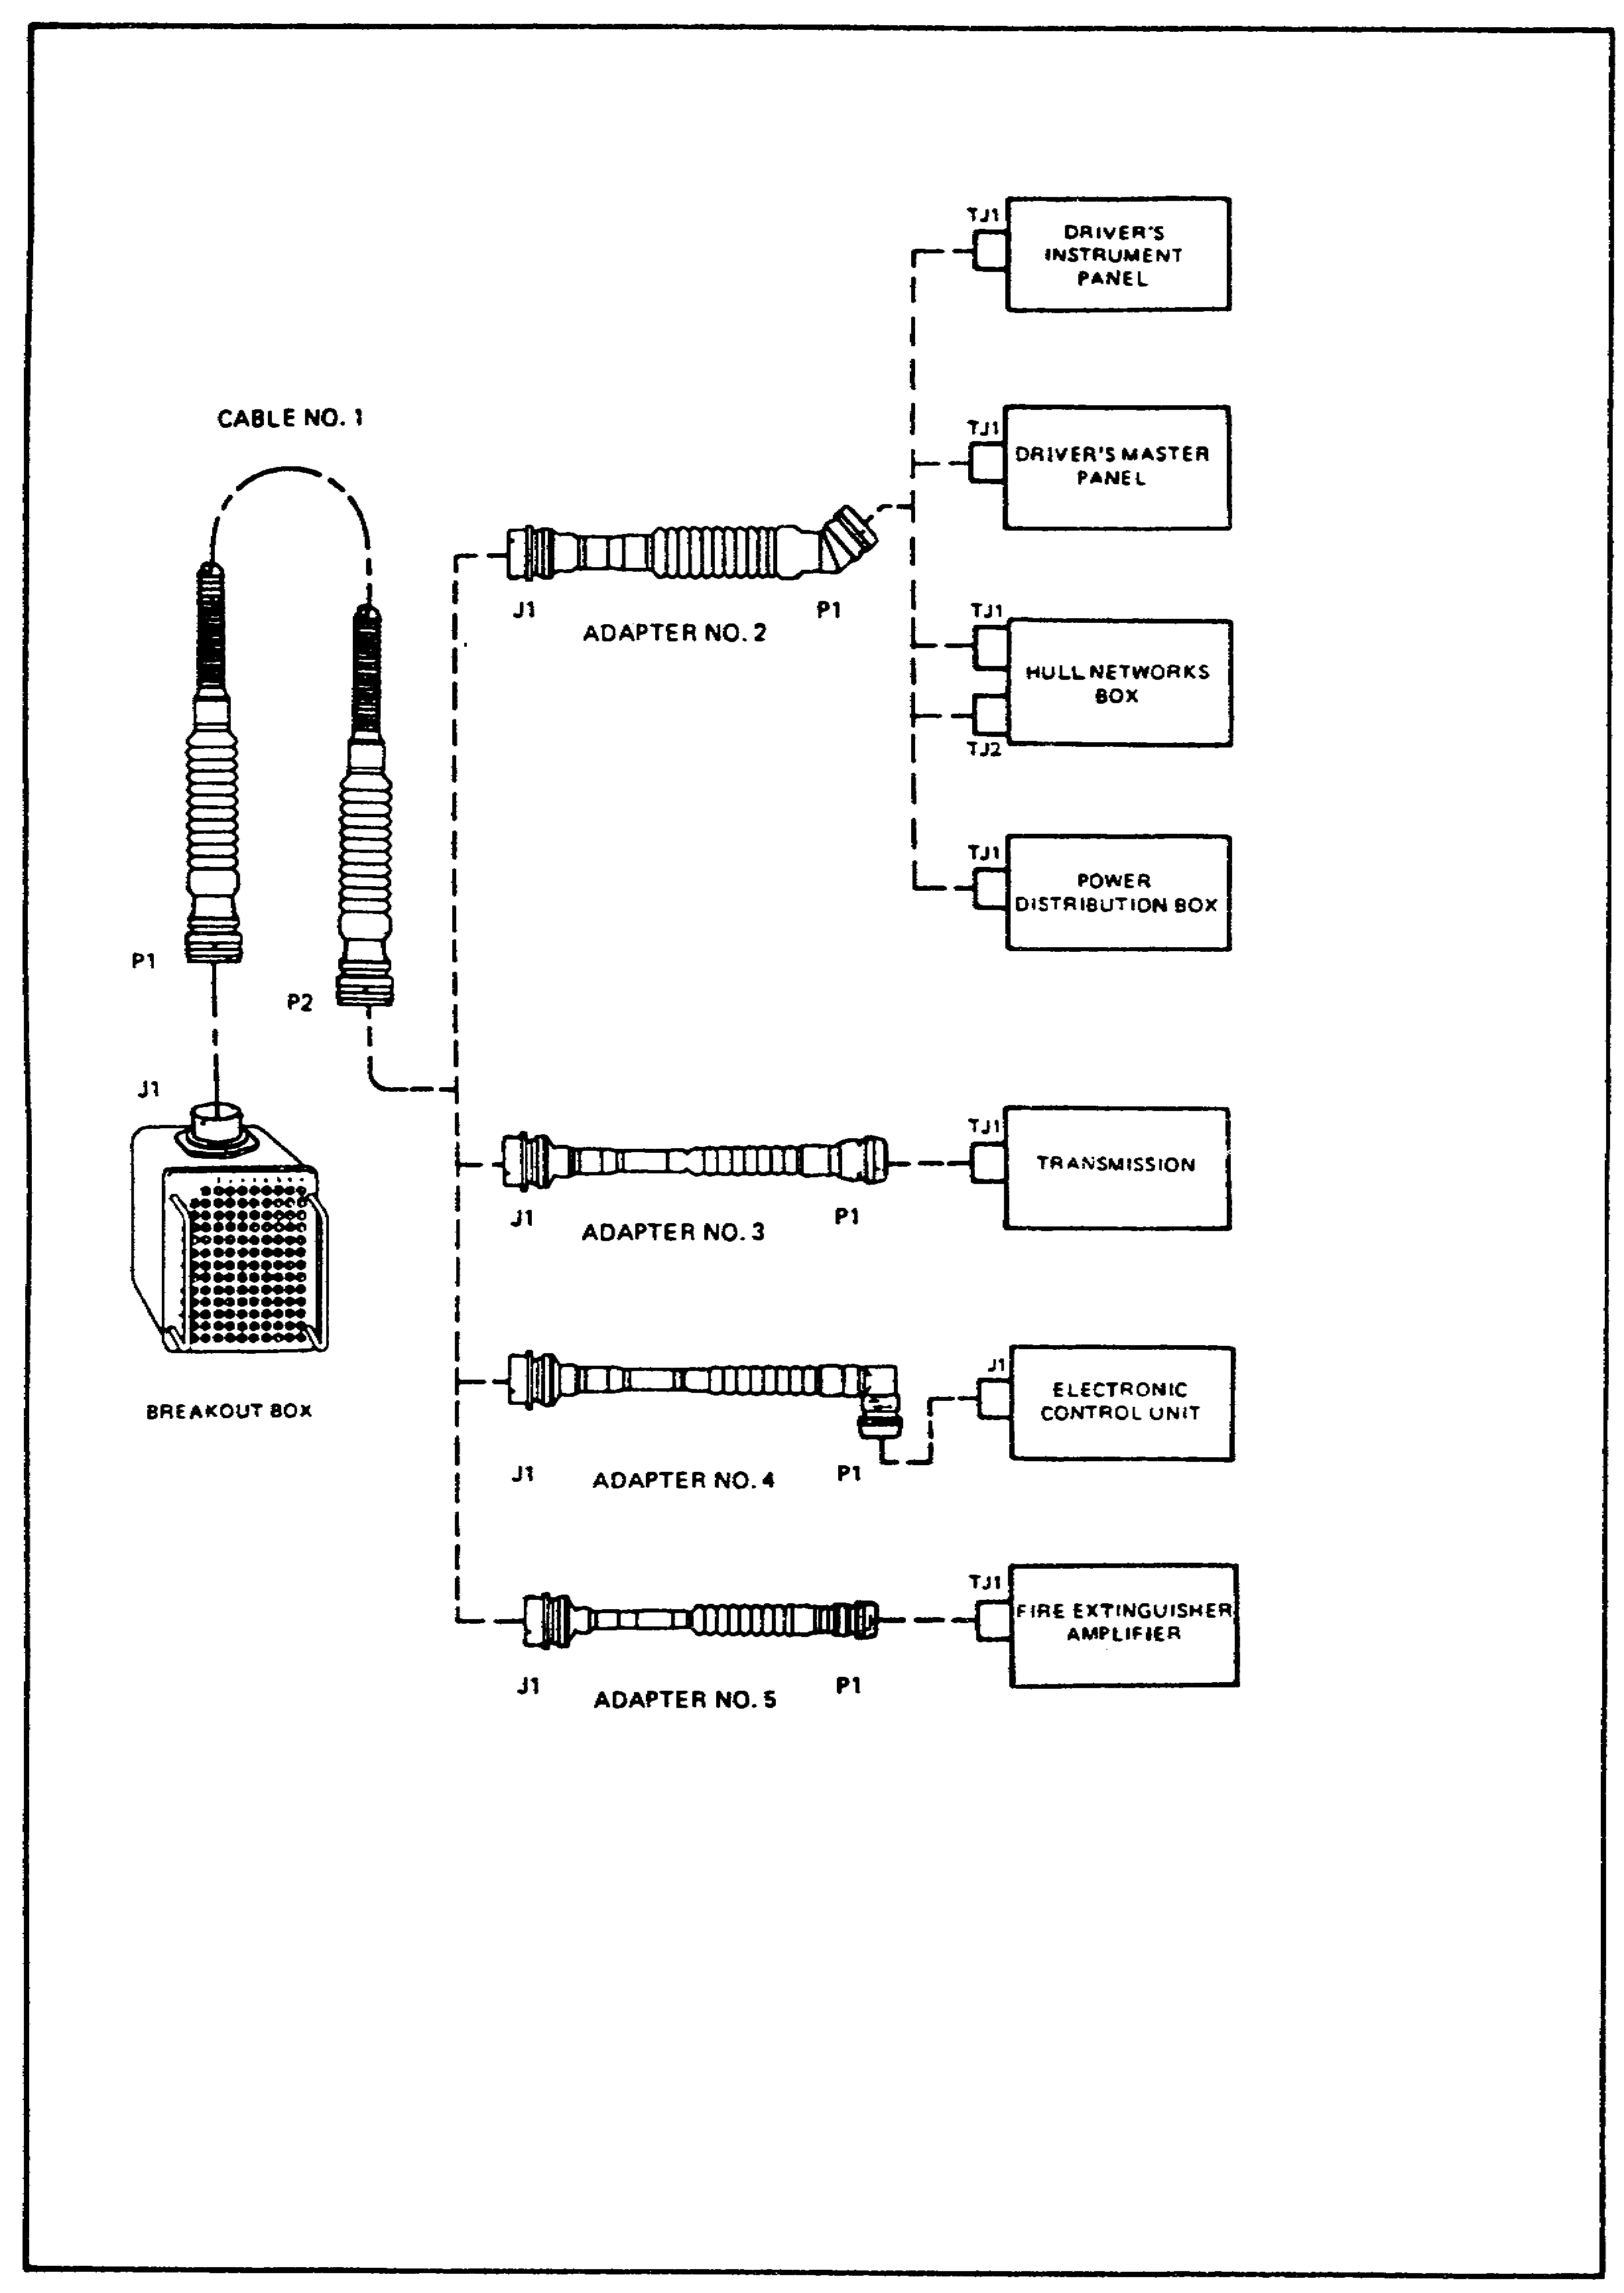

FIGURE 5. HULL COMPONENTS.

27
BAT. DAMAGE ASSES. & REPR. - M1 TANK - OD0485 – LESSON 1/TASK 2

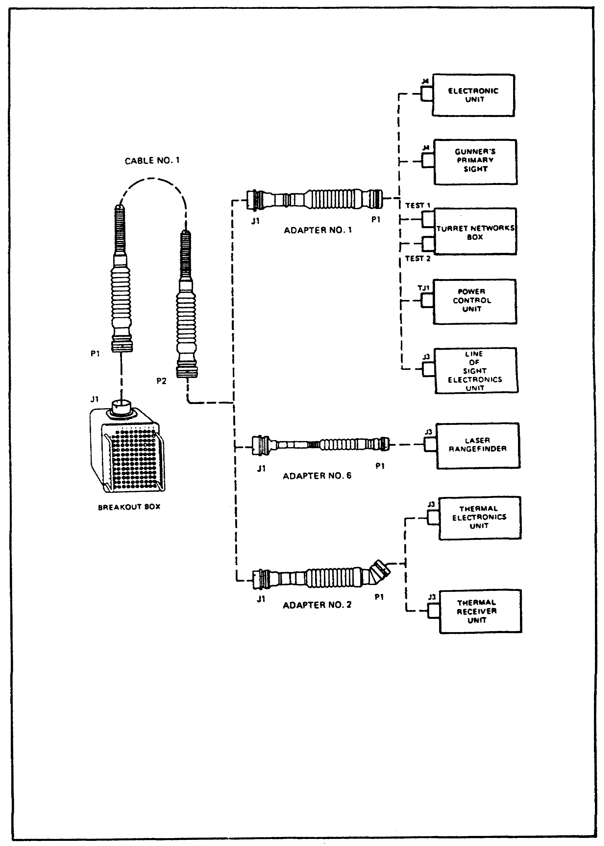

FIGURE 6. TURRET COMPONENTS.

28
BAT. DAMAGE ASSES. & REPR. - M1 TANK - OD0485 – LESSON 1/TASK 2

(1) Voltmeter. A voltmeter can be made from a light bulb and two pieces of wire. The pieces of wire can be connected to the case and the center terminal of the bulb by solder, twisting, or holding the wire ends against the bulb (see figure 7). The voltage rating of the bulb should be close to the value of the expected voltage being measured. For voltages in the 18 to 30 volts direct current (vdc) range, any light bulb on the driver's master panel, driver's instrument panel, gunner's panel, commander's panel, or gunner's primary sight can be used. For voltages of 5 vdc or less, a two-battery cell flashlight bulb can be used. The presence of voltage will cause the bulb to glow. Polarity of dc voltage does not have to be observed, so alternating current (ac) voltage can be measured, if necessary.

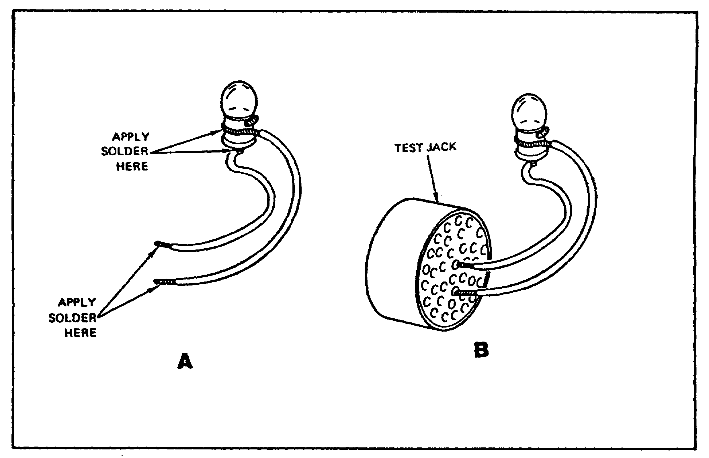

FIGURE 7. FABRICATED VOLTMETER.

(2) Ohmmeter (Continuity Tester). An ohmmeter can be made from a flashlight bulb, flashlight battery, and three pieces of wire (see figure 8 on page 30). When the free ends of the wires are touched to a circuit where continuity (or a short) exists, the bulb will glow. If a two-cell flashlight bulb is used with only one battery, the bulb will glow with one-half its normal brilliance.

29
BAT. DAMAGE ASSES. & REPR. - M1 TANK - OD0485 – LESSON 1/TASK 2

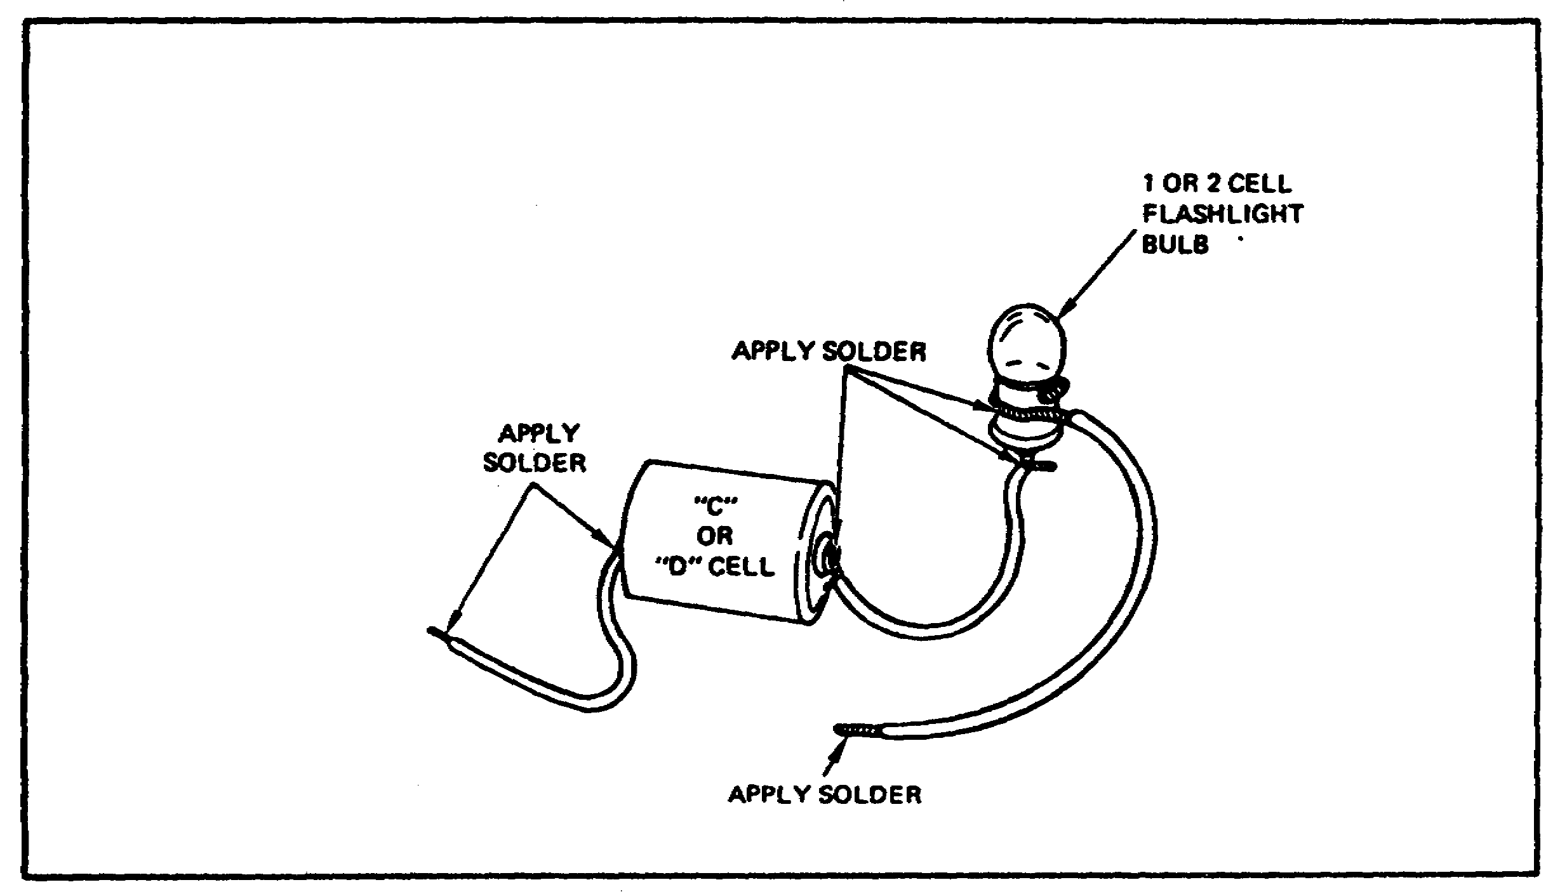

FIGURE 8. FABRICATED OHMMETER.

(3) RF Transmitter Output Tester. The output tester is used to determine if the radio in the tank is sending a signal to the antenna. The following subparagraphs provide two ways of fabricating a RF transmitter output tester.

(a) A RF transmitter output tester can be made from a neon light bulb and a piece of CG-1773 RF cable. Solder the bulb to the cable, as shown in figure 9. Connect the cable to the ANT connection on the front of the radio. When the radio is keyed, the bulb will glow if RF power is present at the antenna connection (this does not verify transmitter frequency accuracy).
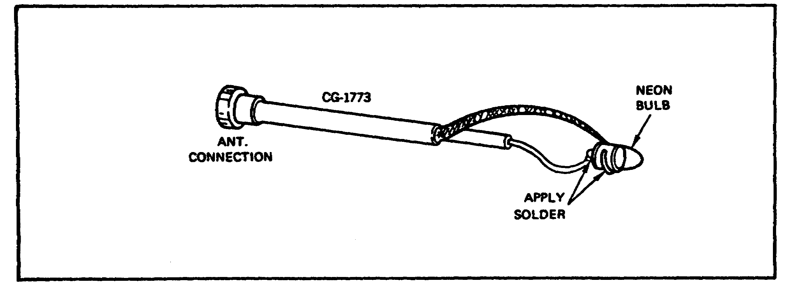

FIGURE 9. RF TRANSMITTER OUTPUT TESTER.
30
BAT. DAMAGE ASSES. & REPR. - M1 TANK - OD0485 – LESSON 1/TASK 2

(b) Another way to check for transmitter output is to hold a common (wood) lead pencil tip a 1/4 inch to 1/8 inch from the ANT connection. If RF power is present, a yellowish-white arc will jump from the connector to the pencil tip when the radio is keyed.

(4) Antenna Output Tester. The antenna output tester is used to determine if the radio is sending a signal from the antenna and it is fabricated as follows:

(a) An antenna output tester can be made from a light emitting diode (LED) and a piece of 10, 12, or 14 gauge wire. Bend an 18 inch piece of wire into a triangle, with the open end meeting at about a 60 degree angle (see figure 10). Add an insulator or other hand grip to the tester for safety. Solder the diode across the open end of the wire.

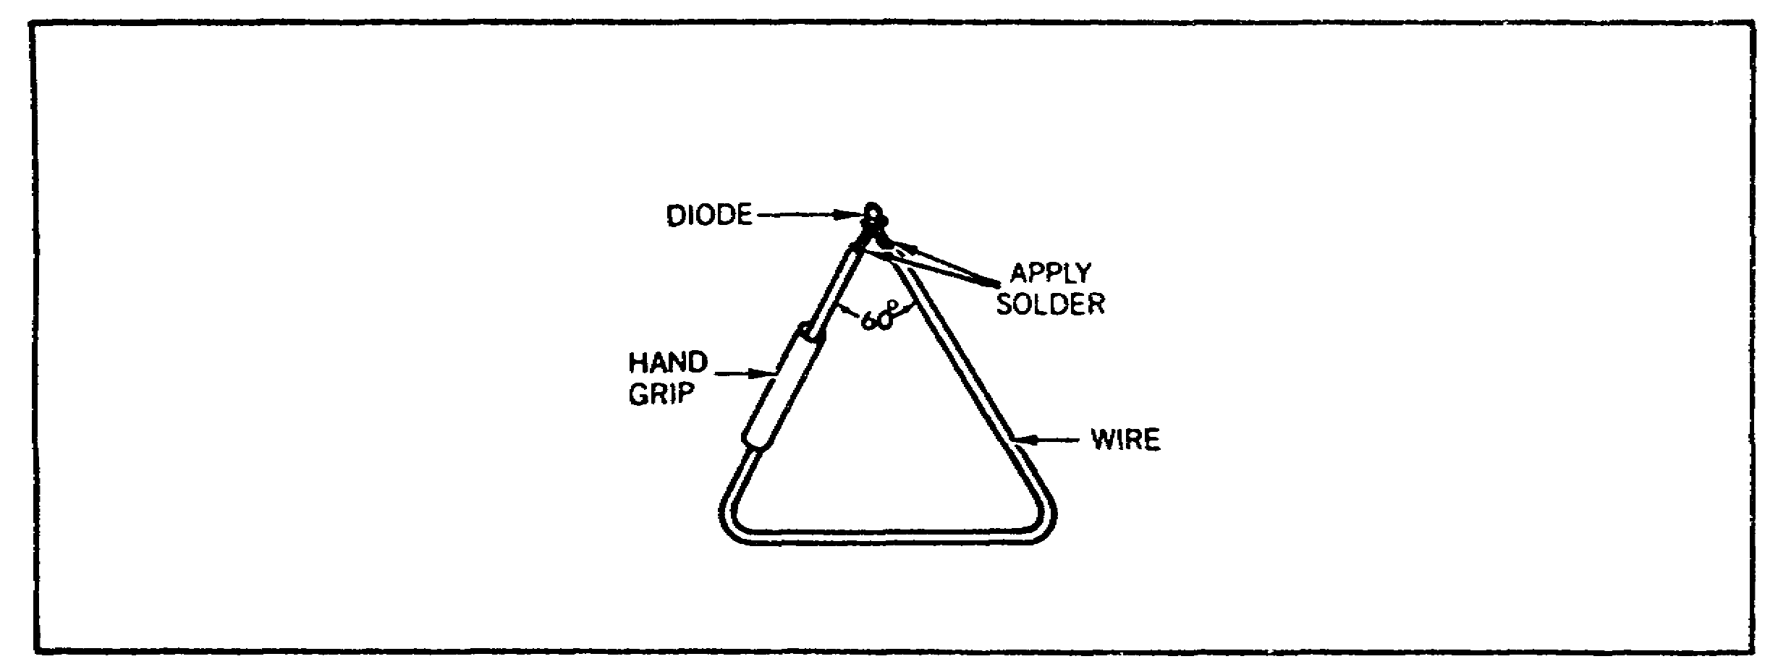

FIGURE 10. ANTENNA OUTPUT TESTER.

(b) Test the antenna output by holding the tester vertically and moving it toward the antenna, watching the diode as the radio is keyed. Do not move the diode too close to the antenna as the diode will burn out. The diode light will give an indication of signal strength. The brighter the light the stronger the signal.

This section provided the instructions that should be used when troubleshooting or performing maintenance on a battlefield damaged M1 tank. The next section will show examples of the battlefield damage that could occur and the necessary procedures for assessment and repair.

31
BAT. DAMAGE ASSES. & REPR. - M1 TANK - OD0485 – LESSON 1/TASK 2

6. Assessing and Repairing Battlefield Damage

The general fault assessment tables that were introduced in paragraph 3g on page 17 of this task, are used when the tank is down and the operator or mechanic is not sure what component is defective. The specific fault assessment tables are used when the operator or mechanic knows the system that is defective but not .the component. This paragraph will provide the specific assessment tables for the engine system and the armament and fire control system, and examples of the steps that should be followed to identify the damaged components.

a. Engine Systems. Physical battlefield damage to the engine systems will be found while doing the preventive maintenance checks and services (PMCS) in TM 9-2350-255-10-1. Any minor damage can be repaired by using the general fixes in TM 9-2350-276-BD. Other battlefield damage can be detected by driver's panel indications, noise, smoke, engine failure and/or a marked loss of engine power. By following the troubleshooting and repair instructions in TM 9-2350-255-10-3, the mechanic can find and fix some of these problems. The procedures used as examples in this section apply to many of the other problems that may be found.

Repair of the engine is limited to swapping the defective module with a known good one. Repair of the engine systems, such as the air induction, lubrication, fuel management, and electrical systems is done by using the detailed assessment and expedient repair procedures that are found in chapter 3 of TM 9-2350-255-BD. The proper repair procedure can be found by using the fault assessment tables, or by referring to the detailed assessment and expedient repair procedure indexes found in the back of chapter 3.

For this task, the proper procedure will be found by using the fault assessment table. Table 5, on the following page, is the specific fault assessment table for the engine systems. The following examples will describe the assessment steps that are followed to identify a faulty component.

32
BAT. DAMAGE ASSES. & REPR. - M1 TANK - OD0485 – LESSON 1/TASK 2

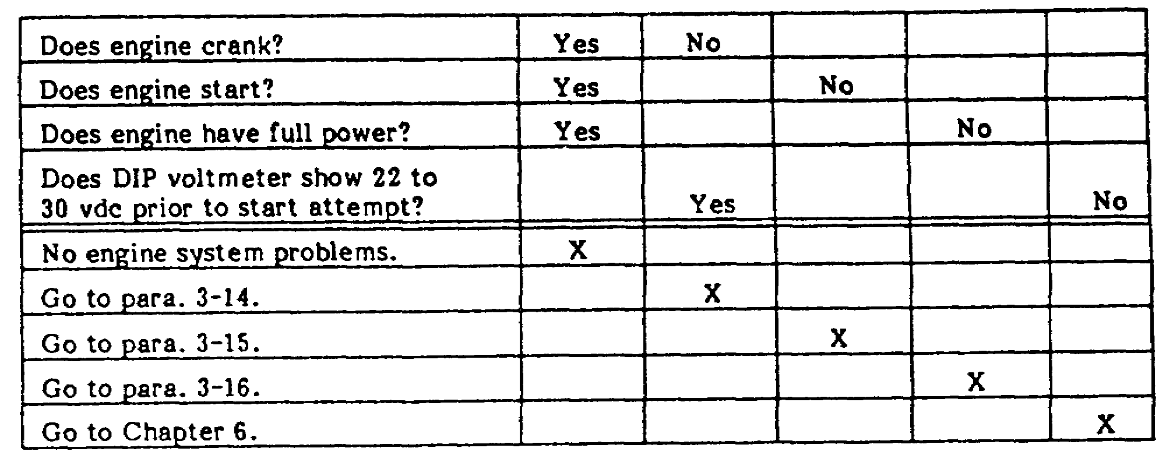

TABLE 5. ENGINE SYSTEM FAULT ASSESSMENT.

(1) Example #1. An M1 tank is in the battlefield with engine problems. The observable symptoms are: the engine cranks but will not start. Table 5 will be used to assess these symptoms.

The first question in table 5 asks, "Does engine crank?" For the above example, the answer would be yes. Now, proceed to the next question, which is, "Does engine start?" The engine does not start for this example, so go across the table until the word no is reached and move down that column.

Moving down the "no" column leads to an "X". By following the "X" across to the left, the mechanic is referred to a detailed assessment procedure that is located in para. 3-15 of TM 9-2350-255-BD. This procedure will determine the fault, or refer the mechanic to an expedient repair procedure found in the same chapter.

b. Armament and Fire Control. The fault assessment and expedient repair procedures needed to repair battlefield damage to the armament and fire control components are found in Chapter 10 of TM 9--2350-255-BD. These procedures provide maintenance actions which can be performed quickly to restore essential fire control capabilities. All the possibilities are not included; they are representative of the repairs which are possible. The users of TM 9-2350-255-BD are only limited in their actions by their imaginations, knowledge of the system, and basic skills.

33
BAT. DAMAGE ASSES. & REPR. - M1 TANK - OD0485 – LESSON 1/TASK 2

Similarly to the engine systems, the proper repair procedure can be found by using the fault -assessment tables, or the procedure index found in the back of chapter 10. The expedient repair procedures are used to repair or bypass the fire control system components which will allow you to fire one or more of the weapons after receiving battlefield damage. It is up to the tank commander and mechanic to determine which repairs offer the most needed capabilities (i.e. aim and fire the main gun). Use extreme caution when using the armament after doing an expedient repair procedures because most of the procedures bypass the safety features designed into the fire control system.

Table 6, on the following page, is the specific fault assessment table for the armament and fire control system. This table contains the greater number of questions that are required when assessing battlefield damage for the armament and fire control system.

There will be two examples involving the use of table 6 to determine battlefield damage. The first example will refer you to a detailed assessment procedure and the second example will refer you to an expedient repair procedure.

(1) Example #1. The main gun tube on an M1 tank is damaged but turret power can still be turned on. Use table 6, on the following page, for assessment.

The first .question in table 6 asks, "Can turret power be turned on?" For this example, the answer would be yes. Now, proceed to the next question which is, "Is main gun tube damaged?" The main gun tube is damaged for this example, so find the "Y" that denotes the answer yes. Follow the "Y" column down until an "X" is found. This "X" refers to an expedient repair procedure which is found in paragraph 10-53 of TM 9-2350-255-BD and explained below.

The expedient repair procedure for this example is titled: Gun tube damaged; Replace with tube from another tank. The necessary steps to perform this procedure are:

(a) General Information: The 105mm cannon tubes from the following tanks are interchangeable with the Mi: M48A5, M60 series, British L7A1, and West German L7A3. These tanks may not be equipped

34
BAT. DAMAGE ASSES. & REPR. - M1 TANK - OD0485 – LESSON 1/TASK 2

with muzzle reference sensor mountings or thermal shrouds, but still can be used as replacements, with the gun operated normally.

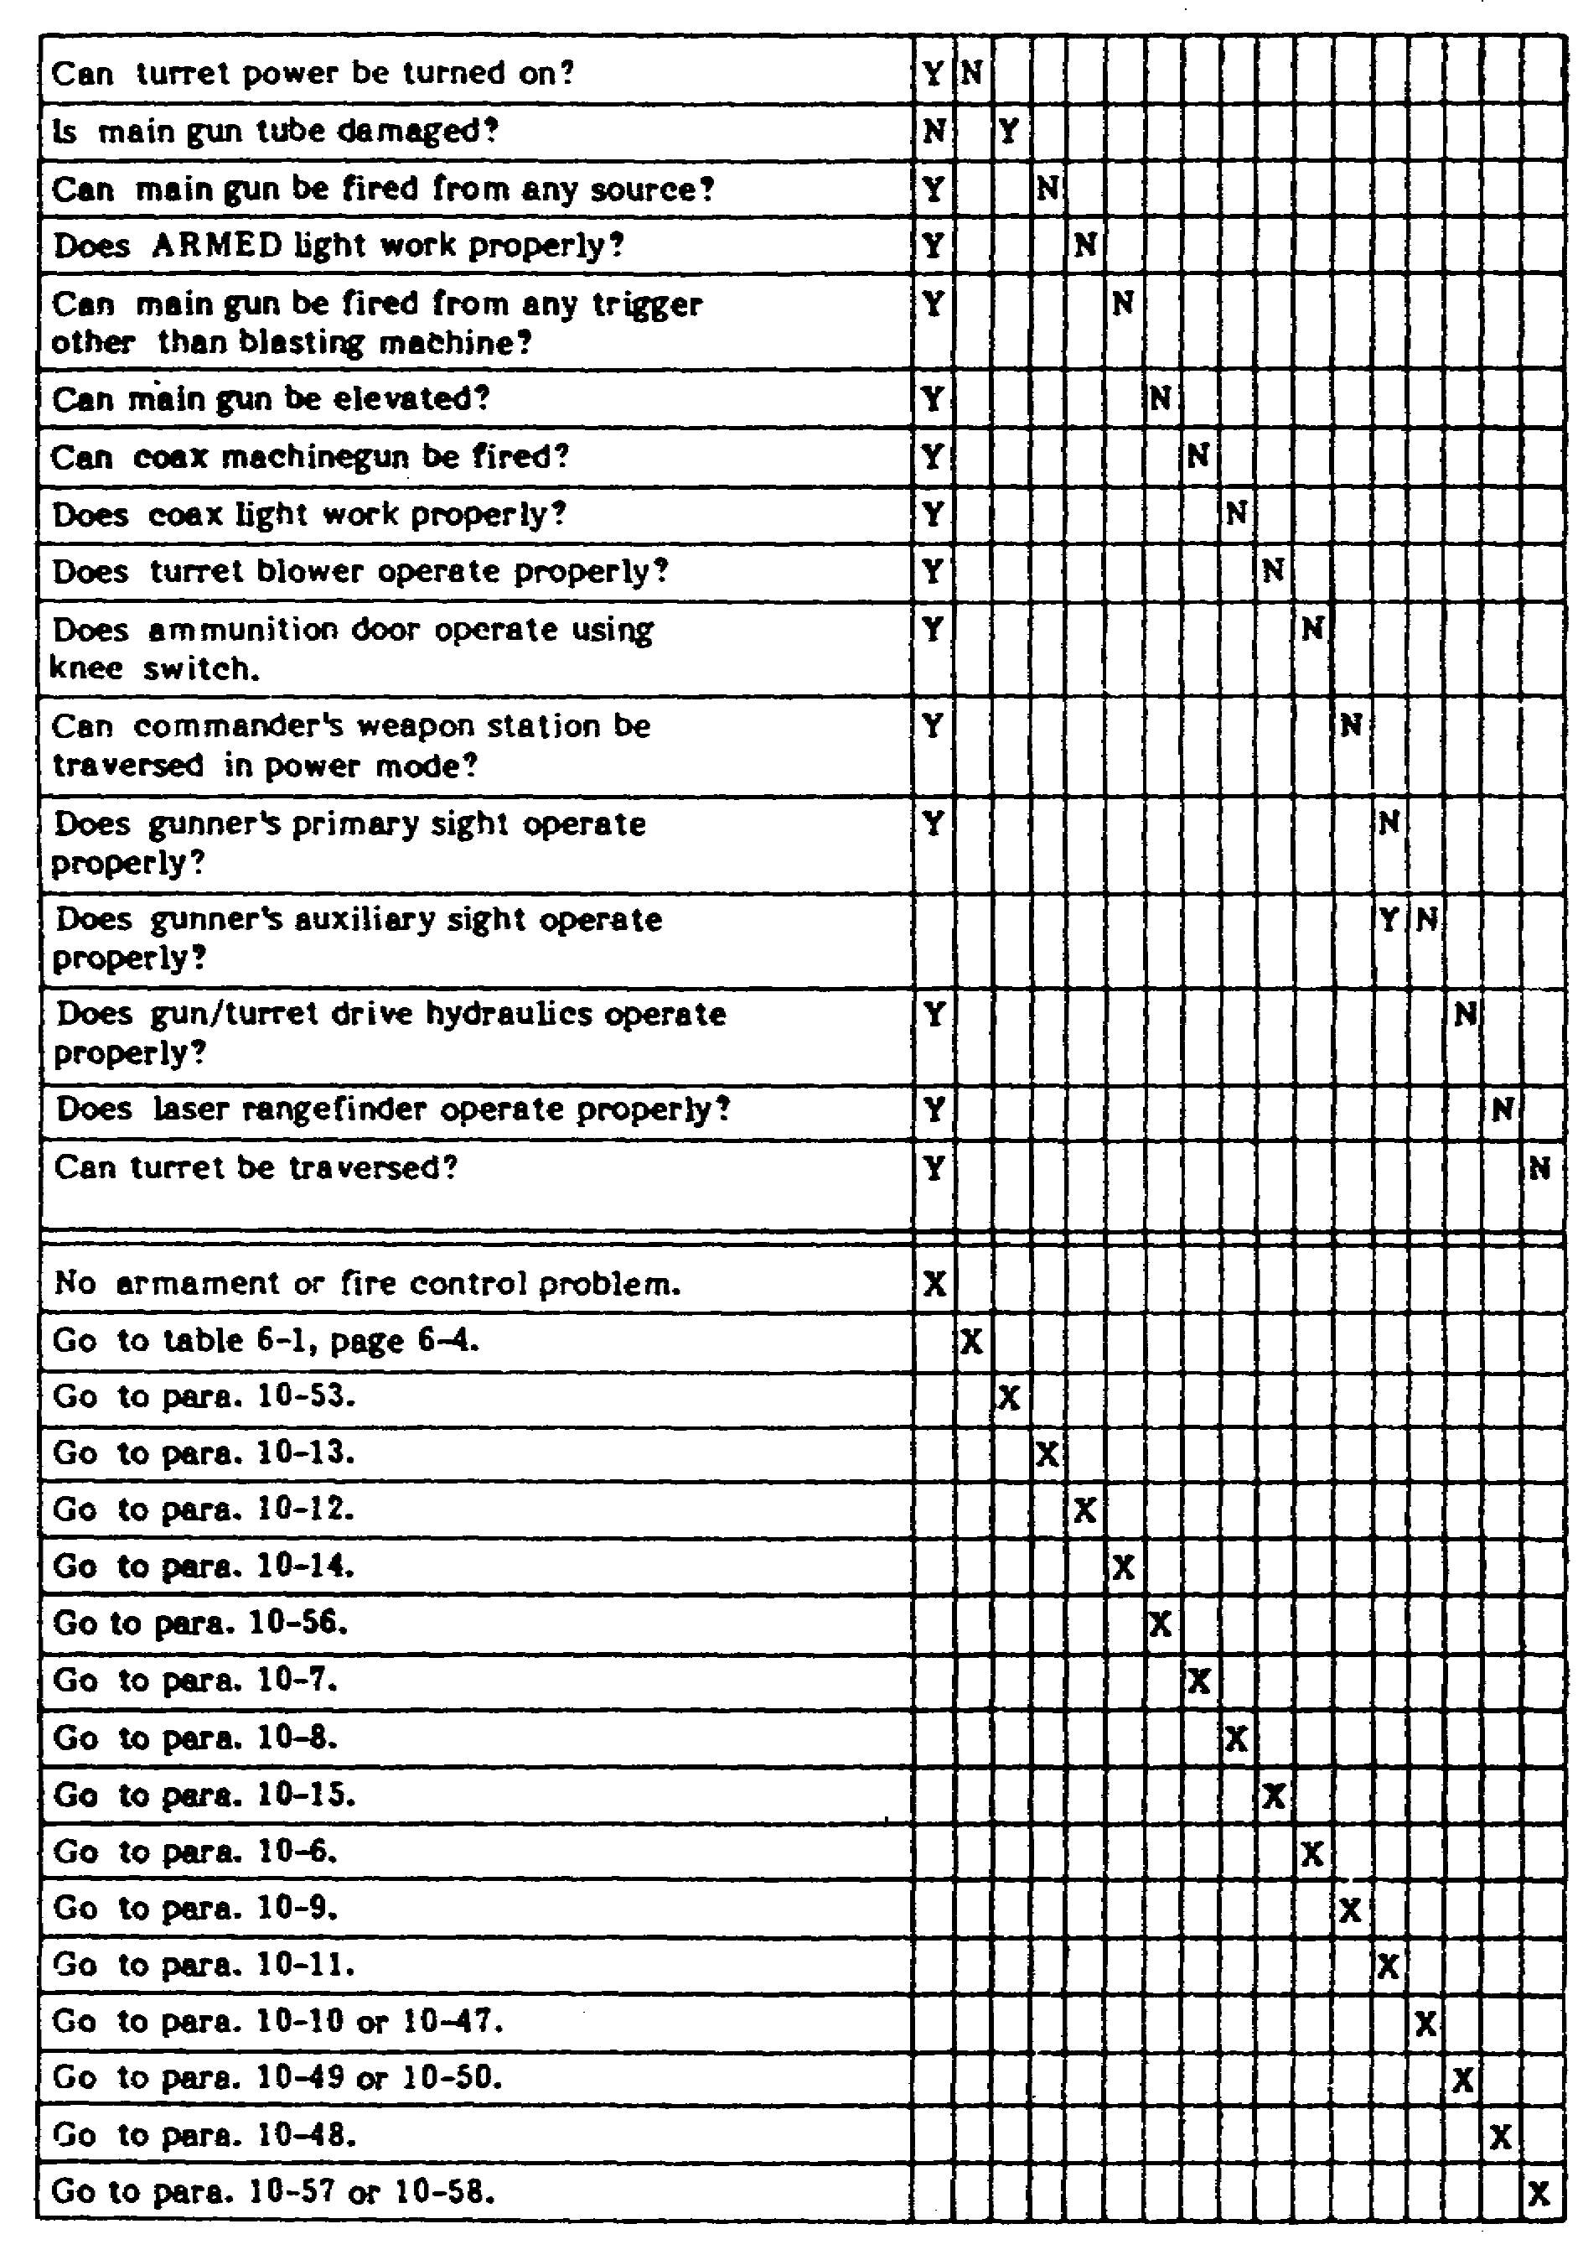
TABLE 6. ARMAMENT AND FIRE CONTROL FAULT ASSESSMENT.

35
BAT. DAMAGE ASSES. & REPR. - M1 TANK - OD0485 – LESSON 1/TASK 2

(b) Limitations:

- Possible decreased accuracy.

(c) Personnel/Time Required:

- Two soldiers.

- One hour.

(d) Materials/Tools:

- Lift capability.

(e) Other Options: If lift capability is not available, the mechanic would refer to paragraph 10-34 of TM 9-2350-255-BD. This paragraph is titled: Main gun cannon tube is unserviceable; recovery vehicle is not available.

NOTE

Refer to figure 11, on the following page, when reviewing the procedural steps.

(f) Procedural Steps:

- Remove thermal shrouds (heat shields); if applicable.

- Attach the boom from the wrecker around the tube.

- Remove the pin holding the gun tube in place.

- Using the girth or spanner wrench, remove the gun tube. Now, attach a guide rope to the end of the tube and remove the assembly.

- Reverse the above steps to install replacement tubes.

- Record the BDAR action taken. When the mission is completed, as soon as practicable, repair the tank, using standard maintenance procedures.

(2) Example #2. An M1 tank cannot be fired from any source even though turret power works and the tube is not damaged. Use table 6 on page 35 for assessment.

36
BAT. DAMAGE ASSES. & REPR. - M1 TANK - OD0485 – LESSON 1/TASK 2

Similar to example #1, the first question asked in this assessment is, "Can turret power be turned on?" From the above information, the answer would be yes. The next question is, "Is main gun tube damaged?" The main gun in this example is not damaged, so the answer would be no. Now, according to table 6, the next question that would be asked is, "Can main gun be fired from any source?" The answer to this question would also be no. From this point on the assessment table, the mechanic would proceed down the "N" column until an "X" is reached. For this assessment, the X refers to a detailed assessment procedure that is found in paragraph 10-13 of TM 9-2350-255-BD and is described below.
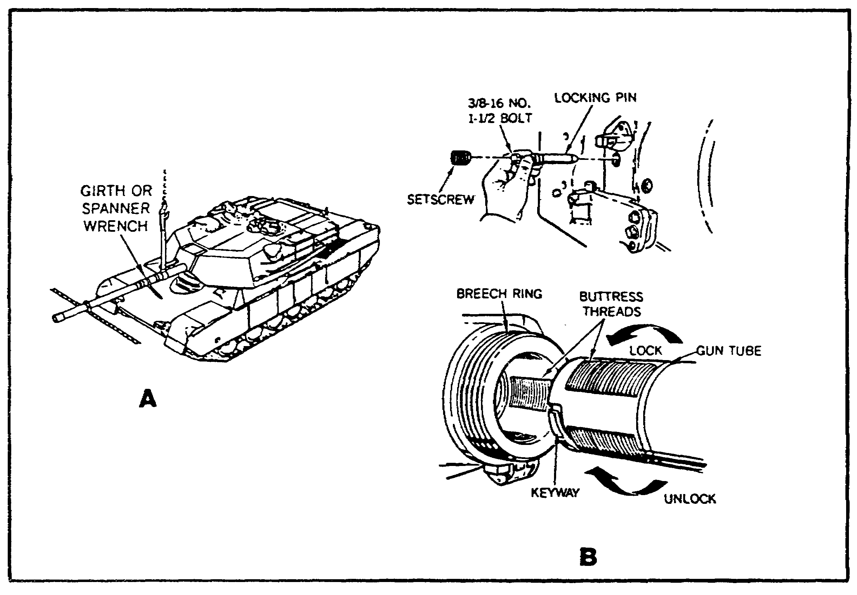

FIGURE 11. REPAIRING THE 105MM GUN TUBE.

The detailed assessment procedure for this example is titled: Observable symptom: Main gun will not fire; armed light OK. The following information is the detailed assessment steps for this example.

(a) Detailed Assessment Steps:

- Make sure that the main gun is free of ammunition.

37
BAT. DAMAGE ASSES. & REPR. - M1 TANK - OD0485 – LESSON 1/TASK 2

- Check that the main gun is IN-BATTERY position (no machined, shiny, portion of the recoil piston visible, forward of the breech ring).

- If main gun is not in IN-BATTERY position, the mechanic would be instructed to go to paragraph 10-36, of TM 9-2350-255-BD, which is an expedient repair procedure titled: Main gun does not fire; main gun does not return to IN-BATTERY position after firing.

- If main gun is in IN-BATTERY position, go
to the next step.

- Turn on turret power.

- Set main gun safety switch (ejector arm) to ARMED.

- Make sure that the ready-to-fire symbol is present in gunner's primary sight.

- Press and hold gunner's palm switch and trigger while checking for 18 to 30 vdc between El- and E2+ on the main gun primer.

- If 18 to 30 vdc was not present, the mechanic would be instructed to go to paragraph(s) 10-40, 10-41, or 10-54. These three paragraphs are all expedient repair procedures that are found in TM 9-2350-255-BD. Paragraph 10-40 is titled: Main gun will not fire; hard-wire blasting machine to main gun, Paragraph 10-41 is titled: Main gun will not fire; hard-wire 24 vdc to main gun, and Paragraph 10-54 is titled: Main gun will not fire; use telephone magneto.

- If 18 to 30 vdc was present, the mechanic would go to the operator's manual (TM 9-2350-255-10-3) for servicing the breechblock.

7. Conclusion

This concludes the explanation of assessing and repairing battlefield damage. The procedures covered in the task were just examples of how to repair a battlefield damaged M1 tank expediently. As stated many times within this subcourse, TM 9-2350-255-BD (in conjunction with TM 9-2350-276-BD) must be used when assessing and repairing battlefield damage for the M1 tank.

38
BAT. DAMAGE ASSES. & REPR. - M1 TANK - OD0485 – LESSON 1/TASK 2

One point that should be remembered is that BDAR fixes shall only be used in combat at the discretion of the commander, and shall be repaired by standard maintenance procedures as soon as practicable after the mission is completed.

39
BAT. DAMAGE ASSES. & REPR. - M1 TANK - OD0485 – LESSON 1/PE 1

PRACTICAL EXERCISE 1

1. Instructions

Read the scenario and respond to the requirements that follow the scenario.

2. Scenario

You are a motor pool sergeant involved in a field training exercise (FTX). You have been in the field for 3 1/2 of the 4 week exercise and luckily nothing major has gone wrong until now. Today, one of the M1 tanks that you're in charge of was hit by a simulated round and your company commander instructs you to repair the tank, using battlefield damage assessment and repair techniques. After relating this information to your mechanics, you are amazed by all the surprised looks. You have this strange feeling that they are not too familiar with BDAR techniques.

To determine how much knowledge your mechanics actually have in BDAR techniques, you decide to give them a sample test.

3. Requirement

Below is a list of questions that you feel will adequately determine the BDAR knowledge of your mechanics. Provide an answer sheet for the questions that follow.

a. Define the term "damage assessment."

b. When a tank meets the needs for specific tactical maneuver or firing missions but all systems are not functional, it would be called ___________.

c. What are the three criteria for minimum functional combat capability (MFCC) of the armament and fire control system on the M1 tank?

d. A battlefield damaged tank has been assessed and the commander must make an initial out-of-action report to the platoon leader. What should the tank commander do if the communication capability is damaged?

40
BAT. DAMAGE ASSES. & REPR. - M1 TANK - OD0485 – LESSON 1/PE 1

e. What steps are involved in a maintenance team (MT) assessment?

f. What are titles of the three general fault assessment tables?

g. What is the purpose of combat damage report forms?

h. What item is commonly used in the assessment and repair procedures as a temporary but effective means of bypassing defective electrical circuits?

i. To make a fabricated voltmeter, the only items needed would be _________________________.

j. What is the purpose of an antenna output tester?

41
BAT. DAMAGE ASSES. & REPR. - M1 TANK - OD0485 – LESSON 1/PE 1

LESSON 1. PRACTICAL EXERCISE - ANSWERS

Requirement

a. Damage assessment is a procedure to rapidly determine what is damaged, whether it is repairable, what assets are required to make the repair, who can do the repair, and where the repair should be made.

b. Combat emergency capable.

c. For the armament and fire control system:

- The turret must traverse 360 degrees and elevate, with no oscillations, either manually or by power.

- The main gun must be capable of firing without damage to the recoil system.

- The tank must have an operational fire control device (primary or secondary).

d. The tank commander should approach the nearest friendly radio and make his report.

e.
(1) Reviewing the crew's out-of-action report.

(2) Interviewing the commander and the crew if available.

(3) Visually inspecting damaged parts and systems.

(4) Performing a self-test.

(5) Making tests with organizational test equipment, if required.

(6) Performing additional vehicle operational tests, as necessary.

f. Mobility, firepower, and communication.

g. Combat damage report forms are used in assessing battlefield damage and are designed to assist commanders in rapidly assessing battlefield damaged equipment, systematically assessing equipment to

42
BAT. DAMAGE ASSES. & REPR. - M1 TANK - OD0485 – LESSON 1/PE 1

determine which subsystem(s) are affected, and the time, personnel and materiel required to effect repair.

h. Jumper wires.

i. A light bulb and two pieces of wire.

j. An antenna output test is used to determine if the radio is sending a signal from the antenna.

43
BAT. DAMAGE ASSES. & REPR. - M1 TANK - OD0485 – REFERENCES

REFERENCES

The following documents were used as resource materials in developing this subcourse:

DA Pam 738-750
FM 3-220
LO 9-2350-255-12
TM 9-2350-255-10-1
TM 9r2350-255-10
TM 9-2350-255-10-3
TM 9-2350-255-BD
TM 9-2350-276-BD

44

